Eyemouth High School – Student guide to home learning 
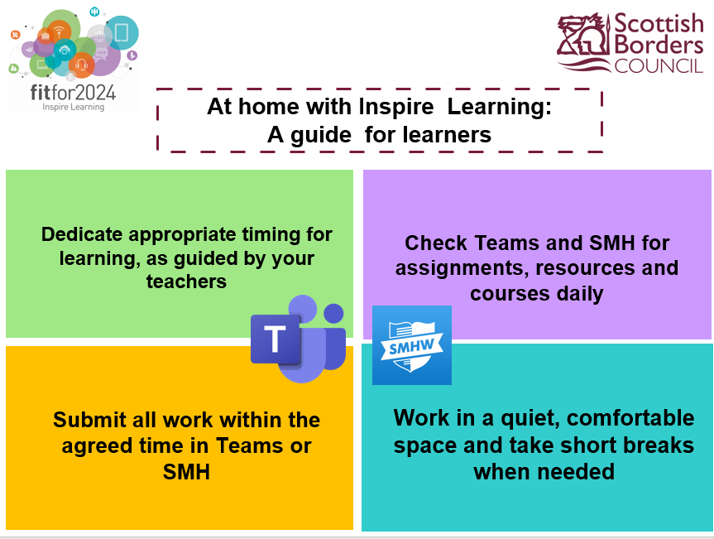

It is important that, during school hours, you are engaging in learning. Your teachers will provide work for you which must be completed.
Check the apps every week day
“Show My Homework” will be used to set all learning tasks. This will be communicated to your parents who will be able to keep track of what you have completed. Teachers will tell you on here how to submit completed work.
“Teams” will be used to upload resources and to chat if necessary. The usual rules of using chat apply – no non learning related chat. There are plenty of other places for general chat.
You can expect different amounts of work for different subjects. As a general principle, if you are in a class three times a week, you will be given three “lessons” to complete, and so on.
Some basic principles to bear in mind when learning

Your learning can happen anywhere with the tools provided by the Inspire Learning Programme in Scottish Borders. On your iPad there are a range of Apps such as Apple and Glow 365 Office to support learners of all ages and abilities remotely.
For secondary school learners, all schools will use Microsoft Teams and Show My Homework apps as the two main ways to collaborate with teachers while at home. You must check both of these apps every day Monday – Friday. There may be other apps or online resources which individual teachers will also use.

What to expect:

- Teachers will plan ‘home learning lessons’ in place of each of the in-school lessons they would normally teach.

- Towards the end of each block of learning be an assessment activity of some kind. Through this, students will be asked to demonstrate their learning and this can be tracked.

- Teachers will be available to help students and answer any questions they have, between 9am and 4pm, Monday – Thursday, and 9am – 1pm on a Friday.

- Students should contact teachers for help using MS Teams or by Glow e-mail. Teachers will reply within a reasonable timeframe.

- If you have not submitted work as expected, then the school will contact home

- If you have any queries or concerns, including any technical issues with the iPad, then please contact Mr Watson – eyhspwatson@glow.sch.uk

Using the apps
Glow
Glow is Scotland's nationally available digital environment and can support learning across the whole curriculum. Glow is not just one place or platform, instead it offers a username and password that gives access to a number of different web services. On the ipad, this information is already pre-populated for the Microsoft 365 Apps
Glow is restricted to learners and educators to ensure that it is a safe online environment. Your child will have a unique Glow username (****@glow.sch.uk) and password in order to access Glow.
If you have forgotten your password, please contact the school.


MICROSOFT TEAMS

An Introduction to Microsoft Teams
Microsoft Teams allow members of a team (in our case a class and their teacher) to communicate and share resources with one another over a secure platform.
Learners should have Microsoft Teams installed on their iPads, if not please download from the ‘self service’ app

Step 1: Finding your class Team page
Within Microsoft Teams, you may be part of a number of different teams. Each team has its own dedicated space for collaborating and sharing resources where only people who have been added to that team can access. (If you can’t see them listed select ‘Teams’ at the bottom of the page.)
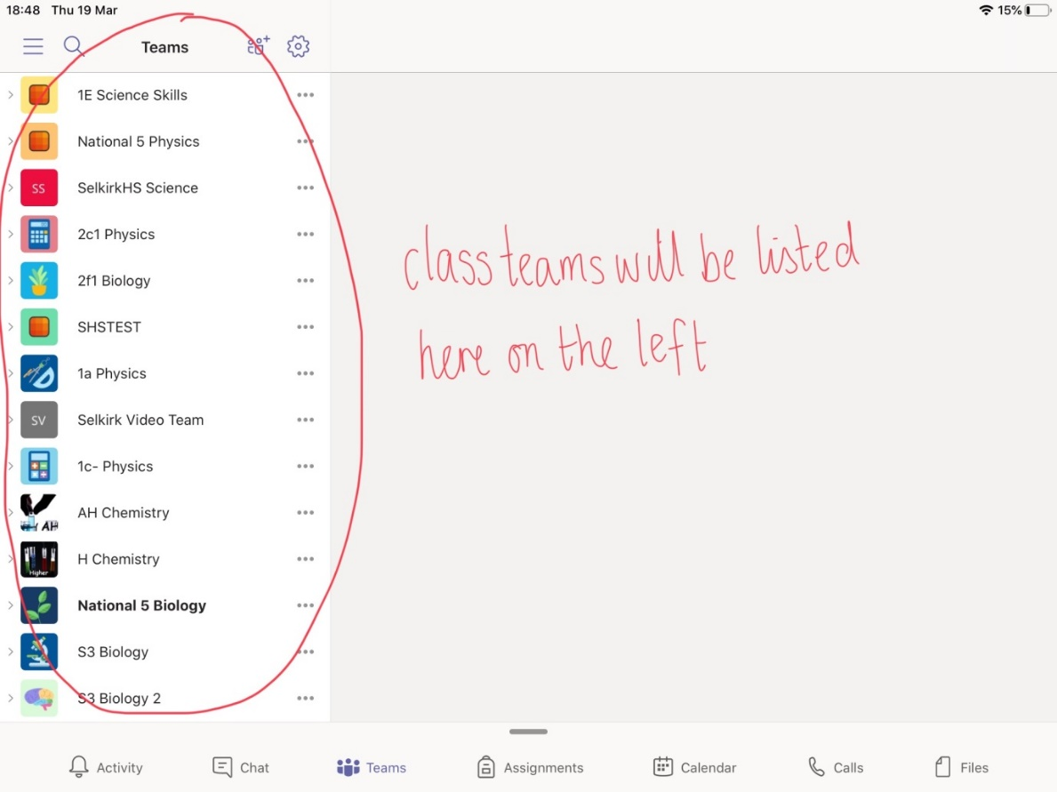

Step 2: Using the Posts feature
Once clicked on your class Teams page you will be able to see about three tabs along the top of the screen. The first of these which we will focus on is ‘Posts’.
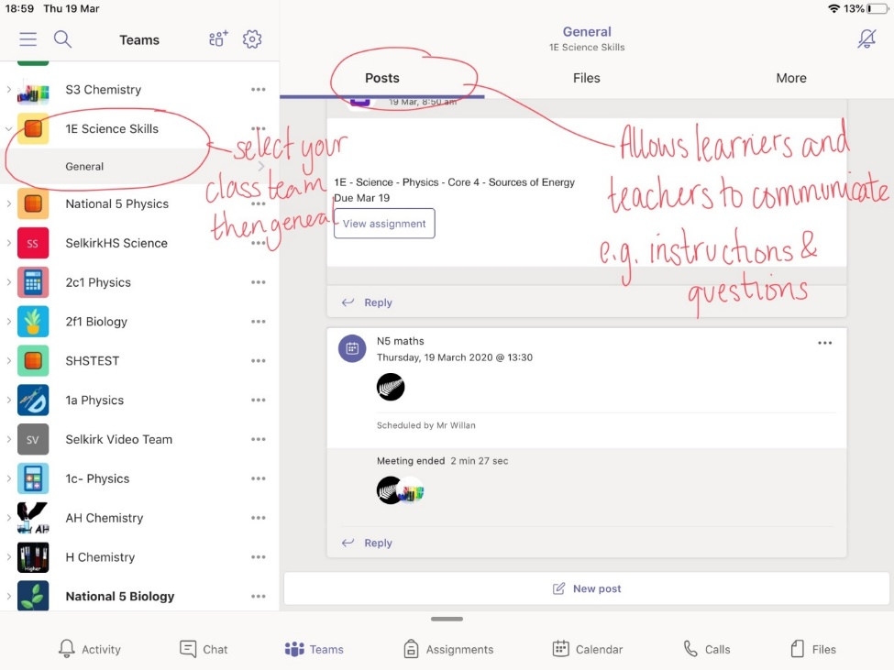

The ‘Posts’ section within Microsoft Teams will allow learners and teachers to communicate with one another within a secure page. If the learner is muted, communicate with the teacher via email (Outlook)
Learners given access to this feature MUST use it sensibly – for adding questions and comments regarding learning. This will ensure important messages are not missed. Students failing to meet these expectations will be muted.
Learners and teachers can also use this feature within teams to attach documents by clicking on the small paperclip underneath the comment box and uploading a file. This will be useful for handing in work completed for feedback.
If your teacher has posed you a question or challenge within this section of teams page then we suggest you click on ‘reply’ just below their message to answer rather than typing a comment into the box at the bottom of the page. This will allow all comments relating to a particular topic to stay in the one place.

Step 3: Accessing Files
For home learning it is important that the class teacher has a secure place to share all necessary files with their class. These can be accessed by clicking on the second Tab along the top of the page, titled ‘Files’.
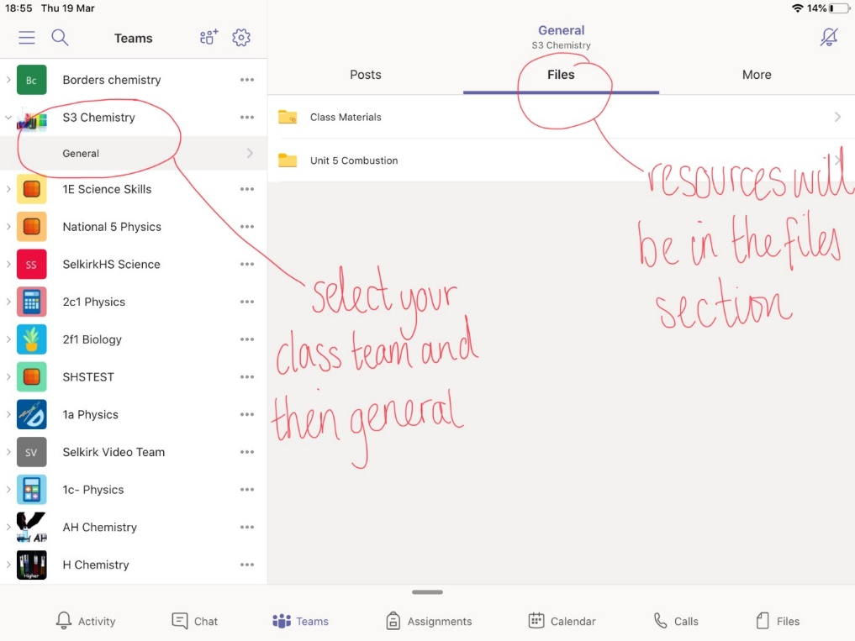

Once you click on the Files tab. This will allow you to see resources which have been uploaded by the teacher.

Step 4: Downloading Resources
To download resources from the class materials section, select the three dots to the right of the file name and select ‘share’, then ‘open in app’.
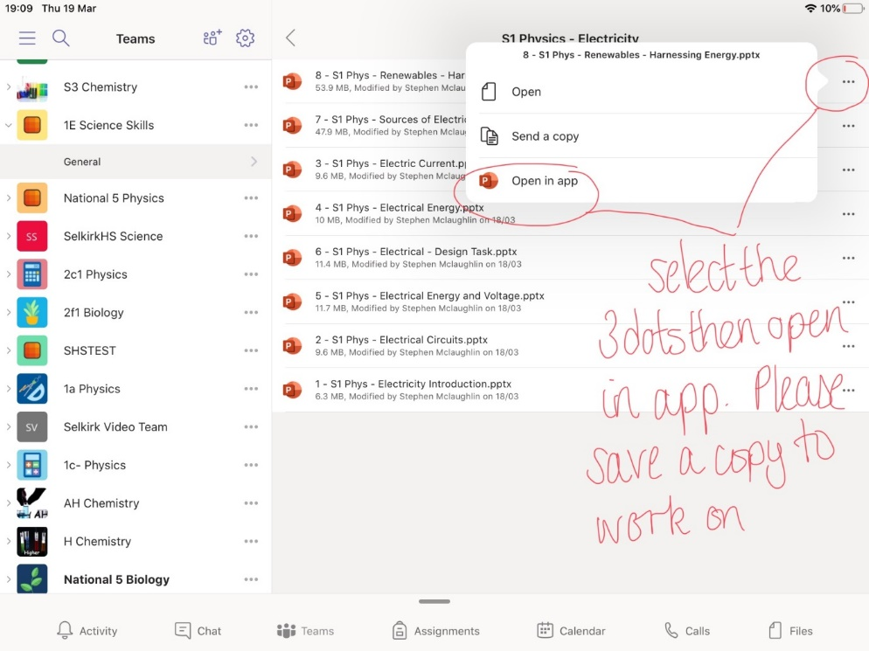

When you open the file, you will need to save a copy by selecting the 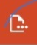 in the top left corner. This can then be edited, (saves automatically) and then returned to the teacher if necessary through ‘Teams’, ‘Outlook’ or ‘Show My Homework’.

One Note
One note is a digital note book. It is organised into sections and pages and allows pupils to type, draw, add pictures of their work and also has audio recording.
Teachers can set up Class Notebooks through teams. Some classes have been using them in class this year. Teachers can send work to a learner’s One Note and then mark it.

To use a Class Notebook for the first time, learners need to sign in to their Class Team (general), select ‘More’ then Class Notebook. It may take some time to set up.
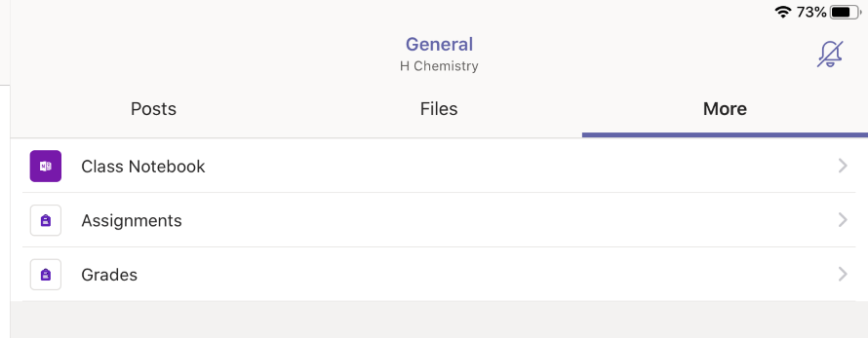

After the first time, the One Note app can be used.


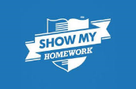
Show my homework

Learners have been using Show My Homework for several weeks now. They should all have an app on their iPad and notifications set up.
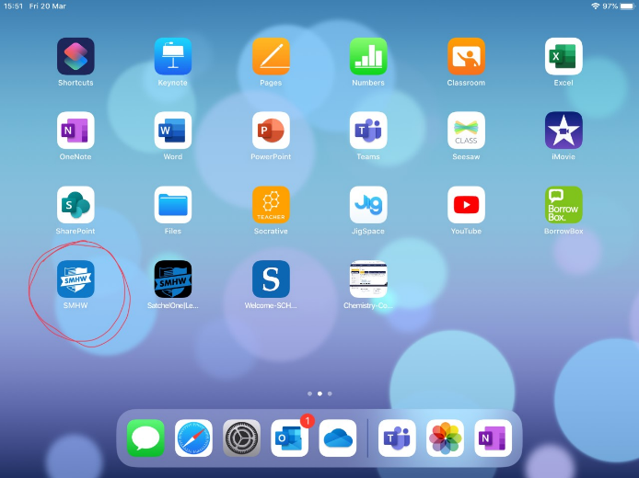

When the app is selected, it opens to the dashboard which shows the tasks due. Selecting a task gives more details about the task and may include attachments. Many tasks will send the learners to the class Team.
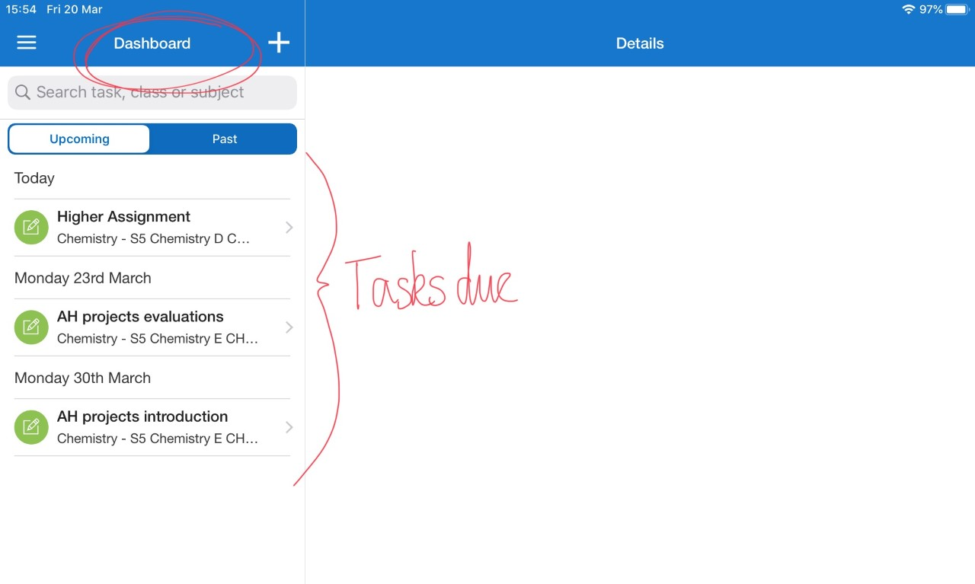
Learners can message their teachers while on the task to ask questions. Teachers will reply when they can.

Show my homework can also be accessed from the desktop site. Search for Show My Homework or Satchel One on a search engine. Sign in using glow email addresses and passwords. It is easier to submit documents using this site than the app. Parents have a unique code to sign in too. Please contact the school office if you do not have yours.

Accessibilty, Immersive Reader and Office Lens
- https://www.lifewire.com/ipad-accessibility-guide-1994516​

- https://wke.lt/w/s/7RWMsc

The iPads have many features to help learners. Go to Settings (the cog) then Accessibility settings. This brings up many possibilities. Most learners will already have chosen settings which suit them.
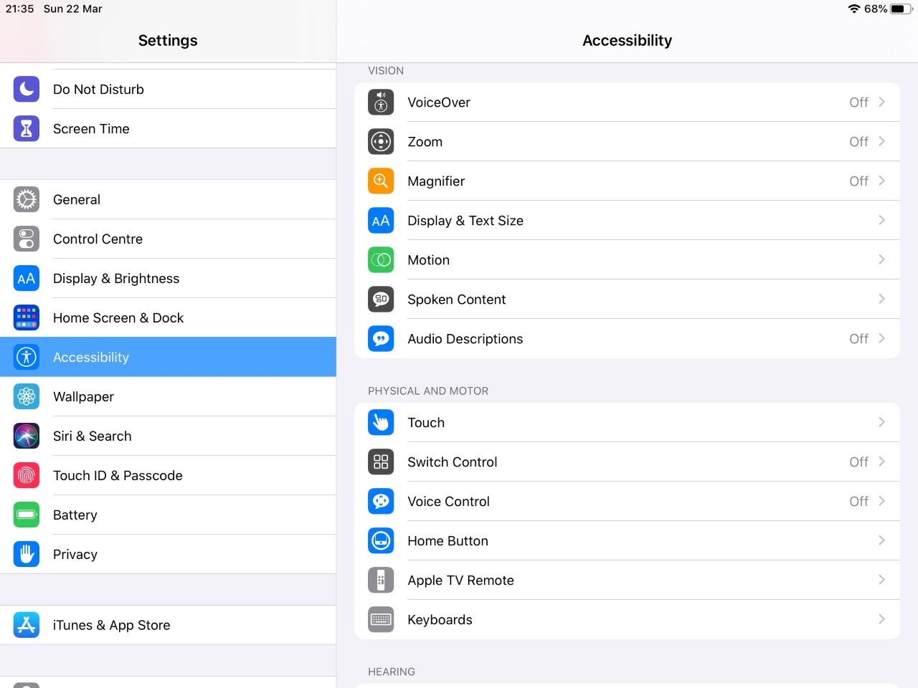

Microsoft Apps have a in built tool called Immersive Reader to improve readability. It has many settings which learners can choose to enhance their experience.
It can be found in the ‘View’ tab.

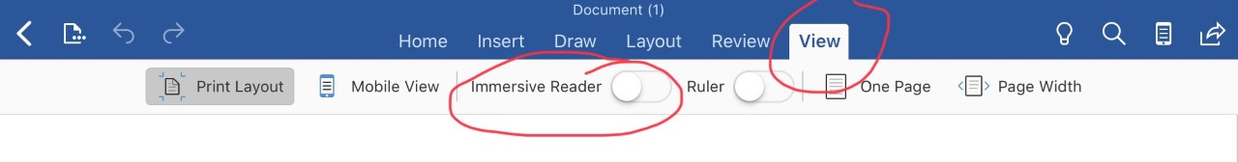

Office Lens is an app on the iPads which you can use to convert images to PDF, Word and PowerPoint files, and you can even save images to OneNote or OneDrive. It can be used with Immersive Reader to help learners read printed documents such as text books.

General troubleshooting

Have you tried turning it off and back on again?

iPads sometimes go wrong or crash. Here are a few tips you can follow to try and get them functioning properly.

- Check for a Software Update
Open the settings app (looks like a cog) and go to General and then to Software Update. If it indicates that an update needed then do it. Also, ensure that Automatic Updates is turned ON.

- Close Apps
Double click the Home button to bring up all of the apps that are running in the background. Swipe each one up to close it.

- Network Reset
Open the settings app (looks like a cog) and go to General then (at the bottom) to select Reset. It will ask for your iPad pin/passcode then select the red reset. The screen will black and an apple appear, it will then ask for your pin/passcode again.

- Hard Reset
Hold down the Power button and the Home button. The iPad will turn off and then an Apple logo appears. Then release both buttons. The iPad will restart after about 30 seconds.

- Proxy Authentication
If you get a pop-up asking you for a proxy authentication you need press settings and enter your username and password. These are the ones you’d usually use on a school computer but the username has to be preceded by cluster4\
The cluster number is associated with your school

Contact the school (eyhspwatson@glow.sch.uk) with any problems and make the subject “iPad Help”. They will try to help you solve the issue.

Other activities
As well as completing work set by your teachers, we strongly encourage doing the following each day:
Literacy: Spend at least half an hour a day reading, preferably from paper, not a screen. If you have access to Accelerated Reader (S1-3) you should quiz when you finish a book.
Numeracy – Spend half an hour on Manga High doing activities directed by your Maths teacher. You can also use the “browse” button to access materials at the appropriate level.
Health And Wellbeing – Do a daily activity as directed by PE teachers.

