S1 Art &Design
Homework 2018
- The Art & Design homework for this first year relates to the projects you will be covering in class.
- Homework is as exciting as you make it, the more effort you put into the work the greater the rewards. Ideas for what to draw can be found on the ‘Eyemouth Art Dep’ Pinterest page-please follow
- Praise and merits will be acknowledged for effort, sustaining standards and improvements in work.
- We look forward to seeing your work in your sketchbook and ask that you get a parent/guardian to sign beside your work when completed.
- Please take care of this sketchbook this is your responsibility

Term 1: August – December | Task | Details of requirements
EHS  Art & Design | Op Art inspired  Sketchbook label | EHS label for  front of sketchbook with Op Art pattern
 | Bridget Riley and Op Art | minimum 5x informative pieces of information recorded in sketchbook
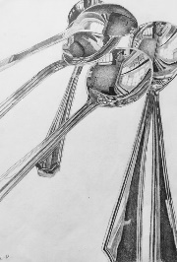 | kitchen cutlery | Draw cutlery in a jar or on a surface. Minimum 3x pieces  - A5 page in your sketchbook -line drawing only
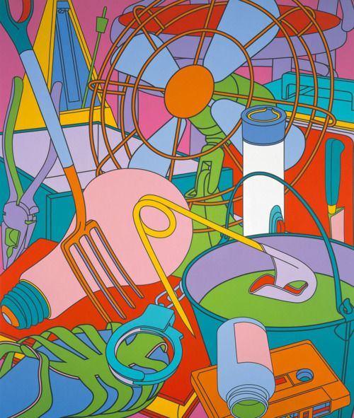 | Michael-Craig-Martin Artist research | minimum 5x informative pieces of information recorded in sketchbook
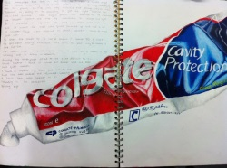 | Toothpaste & toothbrush | - Approx A5 size drawing  - Tonal shading added
Continued… | Task | Detail of requirements
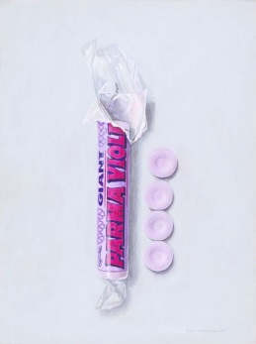 | A packet of sweets or  packet of crisps | - Approx A5 size drawing  - Tonal shading or colour shading
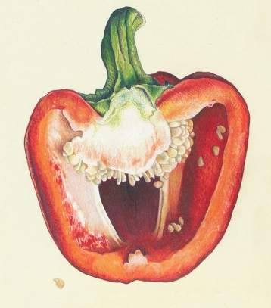 | Sliced pepper | - Approx A5 size drawing  - Tonal shading or colour shading
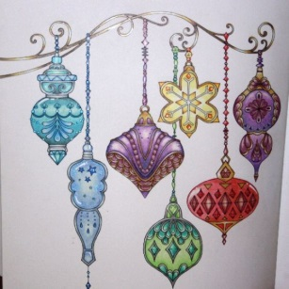 | A Christmas bauble | - Approx A5 size drawing  - Tonal shading or colour shading

