
Corona Isolation Patchwork
When the Lockdown is over and life is back to normal it would be nice to have something that we can build together and which sums up the feelings, the problems and the funny moments of the time when we were at home in isolation. I think it would be good to have something which we can all work on together.
I would like to ask all our children (and any adults too) to create a fabric square decorated in any way they like on the theme of “isolation”. If all the squares are 12 inches by 12 inches (30cm x 30cm) we can then collect them up and sew them together to create a Corona Isolation Patchwork.
Start with a square of cotton fabric 30cm x 30cm. This could be cut out from an old pillowcase, a tea towel or an old shirt or dress. Please try not to use stretchy fabric such as an old T shirt.
Leave a margin around the edge of 1 cm and write your name in the bottom left corner using a marker pen.
30cm
30cm
Cotton fabric
Name here
1 cm margin around the edge

Your design can be created on the fabric in lots of different ways – or a combination:
- with stitches such as embroidery or cross stitch
- by sewing on other bits of fabric (appliqué)
- using paint or pens (Sharpie pens if possible)
- using dyes (Batik or tie-dye?)
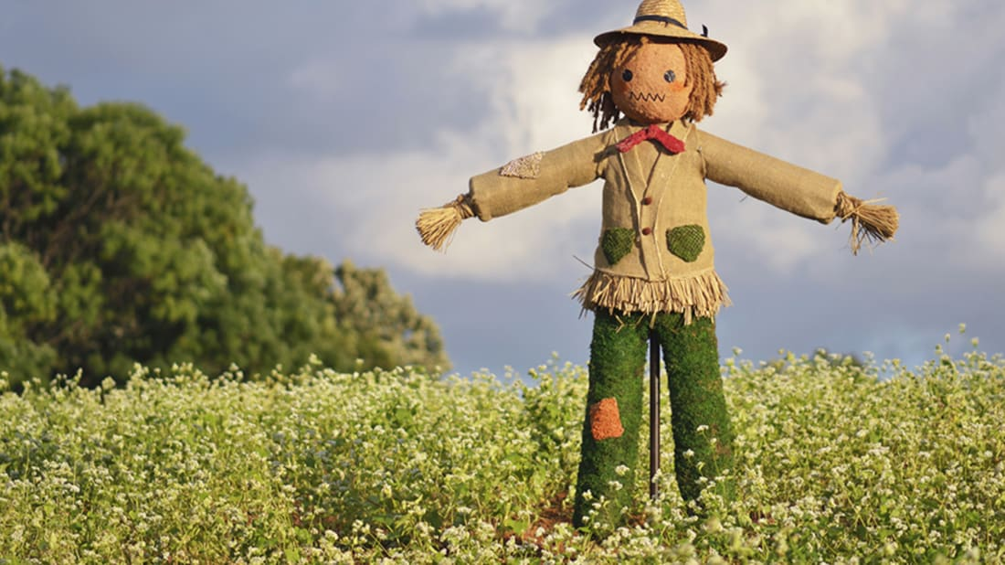
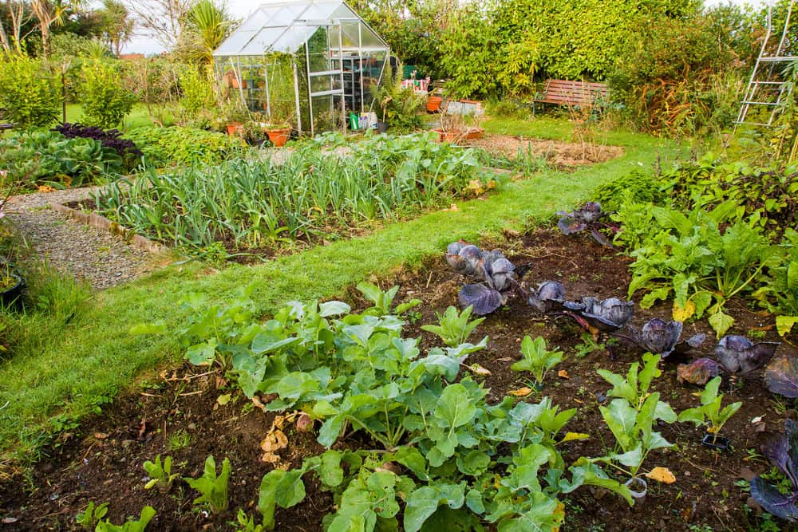
When we are all back at school we will be holding a Celebration event in Ayton with exhibits of work and produce in the Ayton Primary School. This patchwork would be the centrepiece of the displays, along with lots of photos, art work, writing and crafts from the children of all our local schools.

