Matter Wordbank

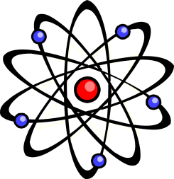
These are some of the important words you will use in your work on materials from the earth. You need to understand the meaning of the words below and you should be able to use these words correctly.

atom the smallest part of an element that can exist

acid rain rain with a pH of less than 7, containing traces of sulfur and nitrogen compounds

chemical property is how a substance reacts with other substances

chemical symbol one or two letters which stand for each element

combustion when a substance burns in oxygen or air and releases energy as heat and light

compound a substance formed from two or more elements which are chemically combined

electrolysis the breaking down of a compound using electricity

electron the negatively charged particle which orbits around the nucleus in an atom

element contains only one type of atom

finite will run out some day

fossil fuels fuels formed from dead plants and animals over millions of years - coal, oil and natural gas

fuel a substance which releases energy when it burns

Greenhouse Effect heat energy enters the Earth's atmosphere more easily than it can leave so the atmosphere warms up

group the vertical columns in the periodic table

matter a general term for a substance which can be solid, liquid or gas. All matter is made up of tiny particles

metals most elements are metals. They are generally hard, shiny elements with high melting and boiling points. They are good conductors of electricity and heat

molecule two or more atoms joined together

neutralisation is when an acid and an alkali react to form water

neutron the particle with no charge in the nucleus of the atom

non-metals non-metals have low melting and boiling points and so many are gases at room temperature. They do not conduct electricity (except carbon) and they are not good conductors of heat

nucleus the centre of an atom

ore a naturally occurring compound containing a metal

particle a tiny piece of matter, too small to see without a powerful microscope

period the horizontal rows in the periodic table

Periodic Table a table that contains the names of all the chemical elements

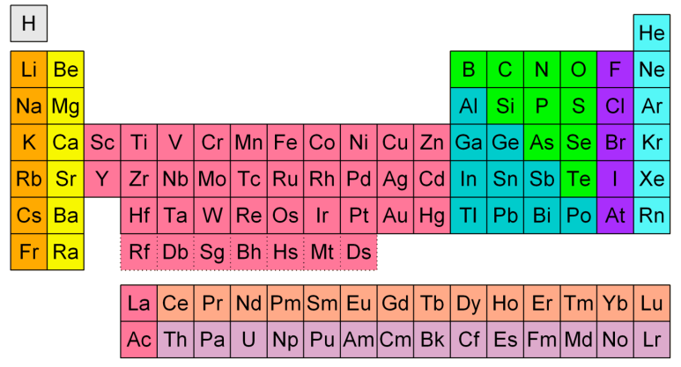

physical property is a property of a material which is not related to its ability to react with other materials, e.g. boiling point, hardness, volume, density, colour, texture

pH scale ranges from below 0 to above 14. tells us how acid or alkaline a substance is. pH 7 is neutral (neither acid nor alkali)

proton the positively charged particle in the nucleus of the atom

reactivity series metals in order of their reactivity, from most reactive down to least reactive

