How to access the Internet if you get a ‘Proxy’ Message – visual guide

Three Steps to get back on the internet!

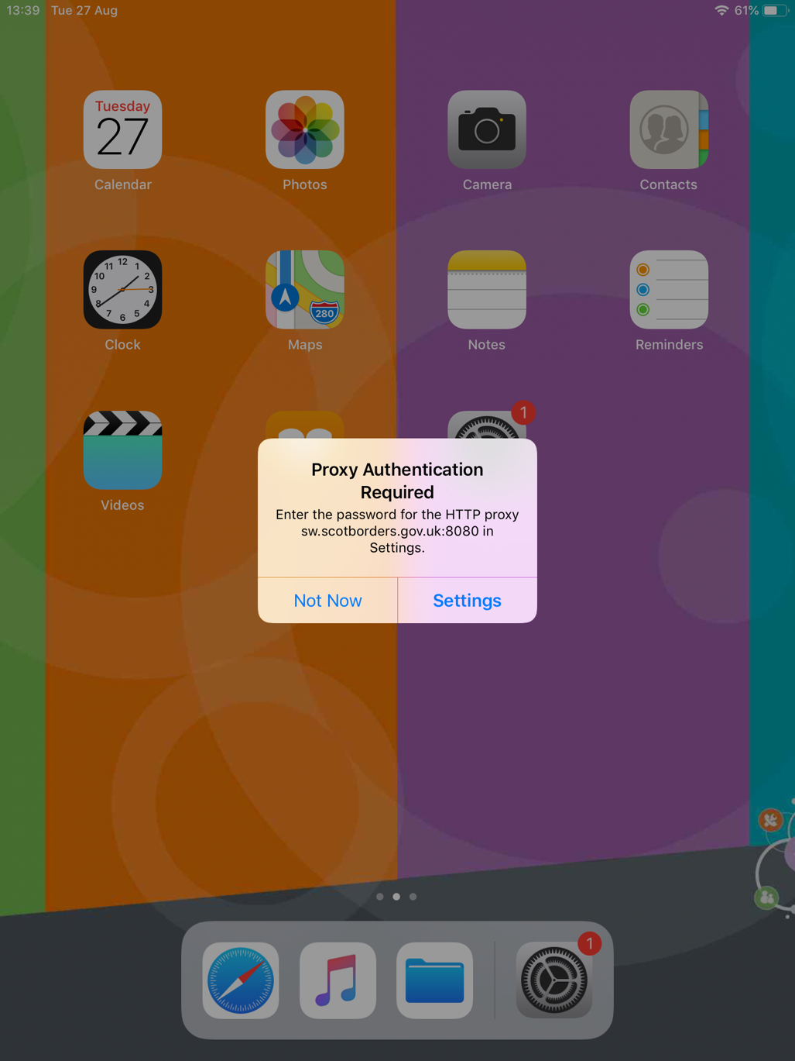
Step 1).

When you get the below popup select ‘Settings’.
Step 2).

You will then see this dialog box, enter your username and password in the following format.

*NOTE*: depending on which school you are in will depend on which number you put after ‘cluster’.

Cluster 1 = Gala Academy
Cluster 2 = Selkirk HS
Cluster 3 = Jed Gram and Kelso HS
Cluster 4 = Berwickshire and Eyemouth HS
Cluster 5 = Hawick HS
Cluster 6 = Peebles HS
Cluster 7 = Earlston HS

Username: cluster’x’\”RMusername”
Password: “yourRMpassword”
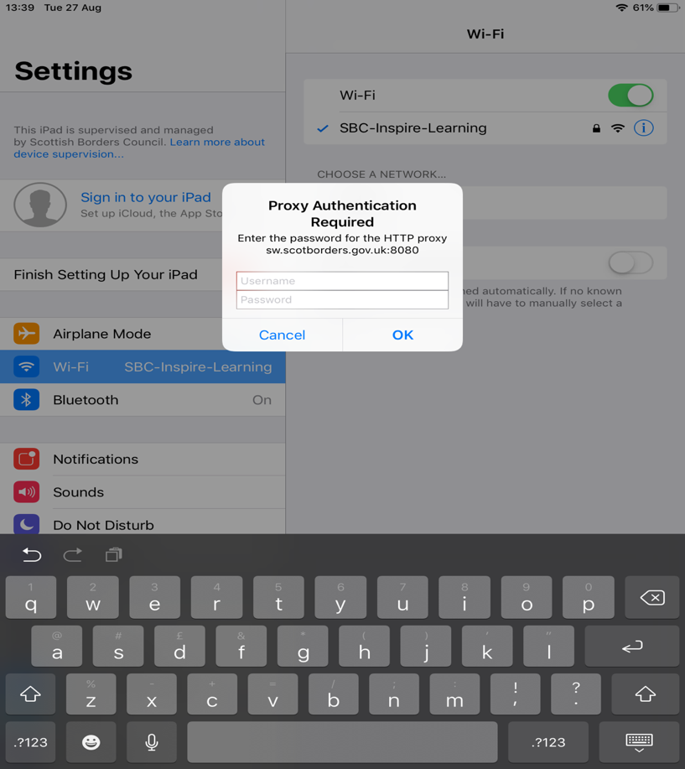
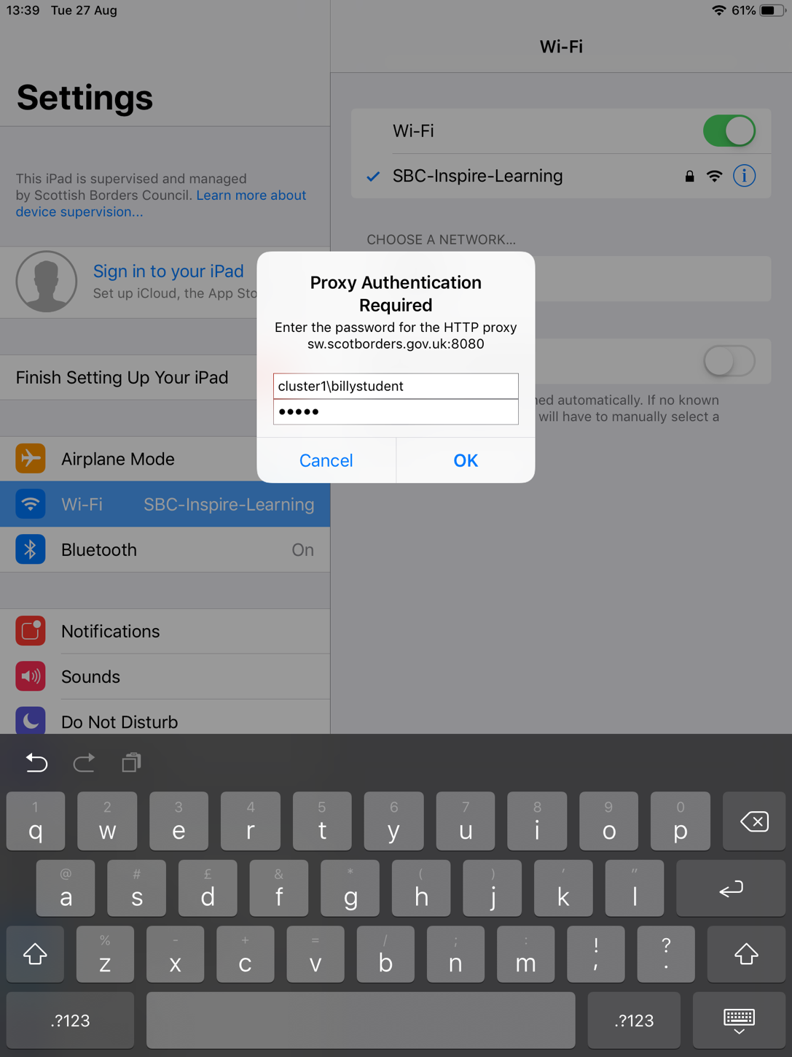
Step 3).

Your box should look something like the below screenshot. Once you are happy with your credentials select ‘OK’ and then try browsing to the internet.

