S1 History- The Vikings
Key Dates
CE 700-1100 | The Viking era in European History.
CE 793 | First surprise Viking raid on Lindisfarne.
CE 795 | First surprise Viking raid on Iona.
CE 806 | Viking raid on Iona that ended in 68 monks being killed.

Key Words

Old Norse | The language spoken by the Vikings.
Scandinavia | The countries of Norway, Denmark and Sweden- where the Vikings came from.
Longship | The type of boat Vikings sailed on.
Berserker | The warrior at the front of the Viking battle who would wear a wolf or bear skin and get into a frenzy.
Pagan | A person holding religious beliefs other than those of the main world religions.
Valhalla | The place where famous Vikings who were killed in battle would end up once they were dead.

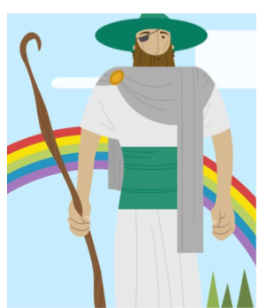
Key People
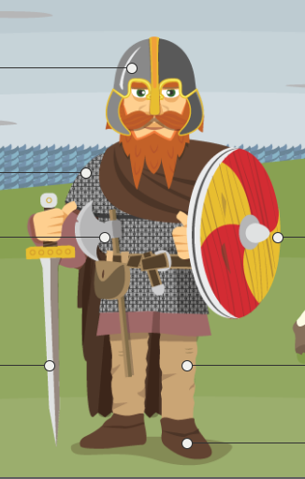
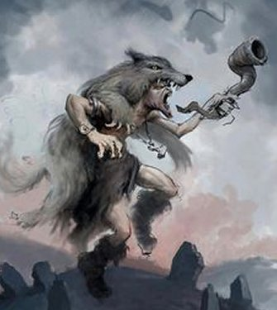
Viking Warrior Berserker Odin

