S2 History-WWII
Key Events
3rd September 1939 | Declaration of war with Germany from the UK and France.
26th May- 3rd June 1940 | Dunkirk evacuation. Small boats sent to rescue BEF and French soldiers trapped on the beach.
10th July- 31st October 1940 | An air battle between the RAF and Luftwaffe over the skies of Britain. The RAF were outnumbered 4 to 1 yet managed to defeat the Luftwaffe.
7th December 1941 | The surprise attack on Pearl Harbour, a military base in Hawaii by the Japanese brought the USA into the war.
1941-1945 | The Holocaust. This saw the mass genocide of over 6 million Jews as well as other minorities.
6th June 1944 | D-Day landings. This was a joint seaborne attack by the British and Americans onto the beaches of Normandy. The attack helped to push the Germans back and regain land in France.
8th May 1945 | VE Day. Victory in Europe is declared after the fall of Adolf Hitler, and the surrender of Nazi Germany.
6th and 9th August 1945 | The dropping of the atomic bombs on Hiroshima and Nagasaki in an attempt to end war with Japan. The bombs were dropped by the Americans and it was a controversial decision.
2nd September 1945 | End of war. Formal surrender of Japan accepted by the US President. Peace has been settled and agreed.

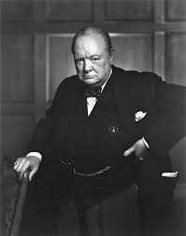
Key People
Winston Churchill- Prime Minister of Britain 1940-1945

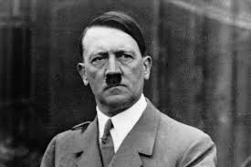
Adolf Hitler- Fuhrer and Chancellor of Nazi Germany 1933-1945

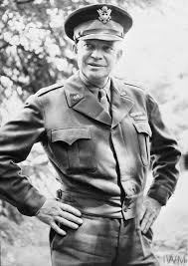

General Dwight Eisenhower- Supreme Allied Commander in charge of D-Day 1944
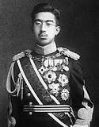

Emperor Hirohito- Emperor of Japan during WWII

Key Words

BEF | British Expeditionary Force. British Army in Western Europe during WWII.
RAF | Royal Air Force. British air force during WWII.
Luftwaffe | German air force during WWII.
Genocide | The deliberate mass killing of a group of people, especially those of a certain nation or ethnic group.
Evacuation | The act of removing or clearing a person or a place.
Minorities | A group that have experienced disadvantage due to a difference from the mass. This could be due to religion, ethnicity, sexuality, gender, race etc.
Allies | The Allies consisted of Britain, USA, France and the Soviet Union.
Axis | The Axis powers consisted of Germany, Italy and Japan.

