S3 History-WWI
Key Events
28th June 1914 | Assassination of Archduke Franz Ferdinand who was heir to the Austro-Hungarian throne in Sarajevo.
4th August 1914 | Declaration of war on Germany after they invaded Belgium and attacked France.
8th August 1914 | Defence of the Realm Act (DORA) 1914- an act to give special powers to the authorities in the UK to protect the people.
Christmas 1914 | Christmas Truce between the Allies( Britain and France), and Germany. Fighting stopped and it is thought that football was played, and gifts exchanged.
1st July- 18th November 1916 | Battle of the Somme- an attack on the Germans near the Somme river in France by the British. This was to relieve pressure at Verdun.
1916 | Conscription was brought into the UK. This was the compulsory enlistment of men to a national service such as the army. This saw many women join the workforce to take over the jobs left by men.
11th November 1918 | Armistice- An agreement between the Allies and Germany to stop fighting, this happened at 11am on the 11th and is remembered each year with a minutes silence.
28th June 1919 | Treaty of Versailles- A peace treaty after WWI that blamed Germany for the war, and made them pay back reparations of £6.6 billion to the Allies.

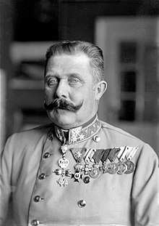
Key People
Archduke Franz Ferdinand- heir to the Austro-Hungarian throne 1896-1914

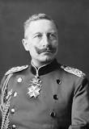

Kaiser Wilhelm II- German Emperor(Kaiser) of Germany 1888-1918

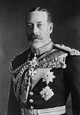
King George V- King of the United Kingdom 1910-1936

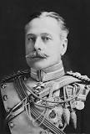
Field Marshal General Haig- Senior officer in the British army, and commander of the BEF from 1915

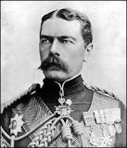
Field Marshal Kitchener- Senior officer in the British army, and known for his propaganda campaign for troops.

Key Words
MAIN | Militarism- the belief that a country should keep a strong military force in order to defend itself.  Alliances- A union or association due to a shared belief, especially between countries.  Imperialism- A policy of extending a country's power and influence through taking over other countries.  Nationalism-Support and belief in your own nation and its interests especially if that excludes other countries.
Assassination | The act of killing someone.
Armistice | A formal agreement between fighting countries to stop fighting.
Propaganda | Information used to promote a political cause or point of view.
Censorship | The suppression of certain information that could be a threat to security.

