
Eyemouth High School

History Department

Advanced Higher History
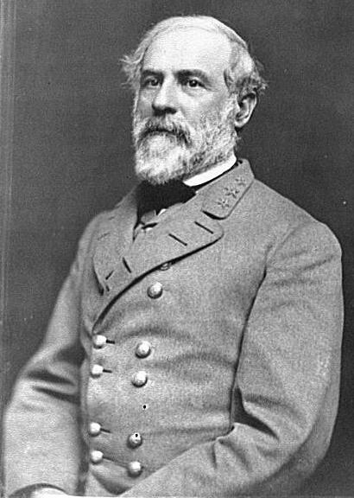
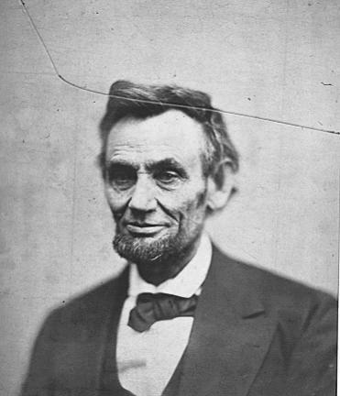
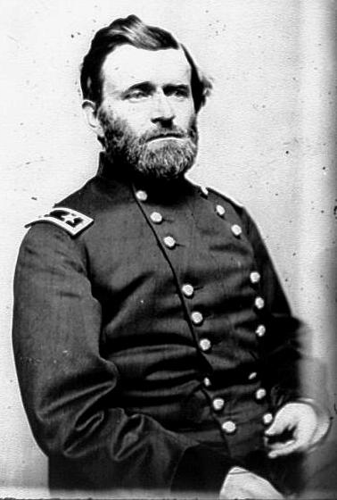
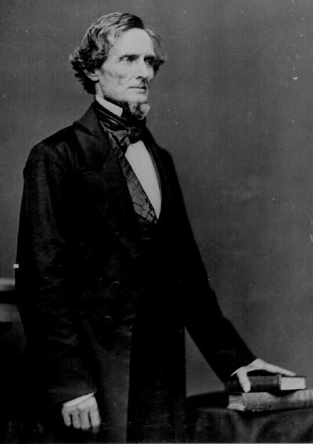
COURSE OVERVIEW

“The House Divided”: USA (1850-1865)

A study of American society, the tensions within it, the causes and nature of the conflict, the political, social and economic outcomes of that conflict, focusing on the themes of conflict, rights, identity and authority.

AMERICAN SOCIETY IN 1850

  - A study of the US political system

- The Democratic and Whig parties.
- Assessment of American society in 1850.
- Economic similarities and differences between North and South
- Social and cultural similarities and differences between North and South
- Political and ideological similarities and differences between North and South
- Role of slavery in the differences between North and South

- SLAVERY IN THE ANTE-BELLUM PERIOD
- The nature, extent and influence of the institution of slavery.
- Arguments in defence of and opposition to slavery.
- The abolitionist movement and its support in the North.
- The impact of the abolitionist movement on the South.

3. THE PROBLEM OF TERRITORIAL EXPANSION

3.1 A study of the process whereby territories become states
- The significance of the Mexican War and the Wilmot Proviso.
- The controversy over the admission of California.
- Compromise of 1850 – its terms and
consequences.
- Popular sovereignty and the fight over the Kansas-Nebraska Act of 1854 and its effects.
- The political impact of territorial expansion.
- The collapse of the Whig Party and the emergence of the Republican Party.
- The ‘slave power conspiracy’
- 1857 Supreme Court decision on Dred Scott
- Increasing influence of the Southern wing of the Democratic Party
- Significance of the 1858 mid-term Congressional elections and the Lincoln–Douglas
debates

4. THE 1860 ELECTION, SECESSION AND THE OUTBREAK OF WAR

- Election of 1860 and its significance
- Reasons for the failure to achieve compromise in 1860–61
- Southern secession after the 1860 presidential election
- Establishment of the Confederacy
- Lincoln’s inauguration and handling of the secession crisis (Failure to achieve compromise)
- Outbreak of hostilities (Fort Sumter and position of Border States)
- Assessment of the causes of the war

5. THE MILITARY CONFLICT

- The nature of the conflict and American society
- Attitudes to manpower, the raising of armies and the issue of conscription
- The impact of technology
- An assessment of Union/Confederate advantages and weaknesses at the start of the war
- The campaigns and the fighting
- Strategy and tactics
- Main theatres of war
- The position of the Border States
- Analysis of the conflict as a first modern war
- The soldiers’ experience of war
- What the soldiers fought for
- Experience of combat and camp life

6. WAR AT HOME AND ABROAD

- Differing approaches and efforts to finance the war of the North and South
- Impact of the war on the economies of both North and South
- Social impact of the war — a shared experience of North and South
- Role of women in the conflict
- Opposition to conscription
- States’ rights in the South
- International dimension

7. LEADERSHIP AT HOME AND ABROAD

- Political leadership
- Assessment of Lincoln’s Presidency, his relations with politicians, generals and the public
- Assessment of Davis’ Presidency, his relations with politicians, generals and the public
- Opposition to the war, North and South, and the issue of States’ rights in the South
- Military leadership, an assessment of Grant and Lee’s military leadership during the Civil War

8. THE EMANCIPATION PROCLAMATION AND ITS CONSEQUENCES
- The emergence of Lincoln’s policy.
- The proclamations of September 1862 and January 1863.
- The immediate and long-term consequences of the proclamations.
- Presidential justification for the proclamation.
- The African-American war effort and the Southern reaction to this.
- International reaction.
- An assessment of the position of Blacks by the end of the war.

9. ELECTION OF 1864
- Significance of military events on the course of the election
- Divisions within both the Republican and Democratic parties
- The platforms of the candidates
- Debate over the issue of Reconstruction
- Analysis of the nature of the 1864 election campaign
- Significance of the 1864 voting patterns
- Outcome of the election

10. Assessment of the reasons for Northern victory and Southern defeat
- Economic: finance; industrial capacity; transport.
- Military: manpower; strategy; generalship.
- Political: leadership; States’ rights.
- Social: morale; home front.

ITALICISED TOPICS CAN BE ASSESSED IN THE SOURCE QUESTIONS

Assessment

There are two different aspects of assessment for Advanced Higher History.

- EXTERNAL ASSESSMENT

The Historical Study part of the assessment will be assessed in a 3 hour exam. The breakdown of the external assessment is as follows.
ASSESSMENT | FORM OF ASSESSMENT | TOTAL MARKS
Part 1 | Two essays each worth 25 marks  The 25 mark questions will use a variety of command words including:  -To what extent was [event] caused by [factor]…?  - How far does [factor] explain.. [event]?  - [quote].. how valid is this view?  - [quote] .. how justified is this view? | 50 marks
Part 2 | Three source questions  The following command words will be used for source questions:  - Evaluate the usefulness of [source] as evidence of..  - How fully does [source] explain..  - How much do [sources] reveal about differing interpretations of.. | 40 marks

- HISTORICAL RESEARCH – THE DISSERTATION

You must produce a 4000 word dissertation on an aspect of the course. You can choose from a selection produced by the SQA. This must be complete by April. The dissertation is worth 50 marks.

