

Promoting Positive Behaviour Policy

At Eyemouth High School, we expect high standards of student behaviour from all of our students. We are clear that the purpose of school is to learn and achieve, and we want all students to feel safe and happy while doing so. This policy sets out a framework for behaviour management – promoting positive behaviour - and outlines procedures to be followed when behaviour falls short of what we expect.

Professional Standards (for teachers)

In managing behaviour, we should all be mindful of the standards expected of us as teachers, as outlined in the GTCS Standard for Registration. Specifically:

3.2.2 Develop positive relationships and positive behaviour strategies

- demonstrate care and commitment to working with all learners;

- demonstrate a secure knowledge and understanding of the wellbeing indicators;

- show in-depth awareness of educational research and local and national advice, and use in a consistent way, a variety of strategies to build relationships with learners, promote positive behaviour and celebrate success;

- implement consistently the school’s positive behaviour policy including strategies for understanding and preventing bullying, and manage pupil behaviour in and around the school, in a fair, sensitive and informed manner;

- seek and use advice from colleagues and promoted staff, as appropriate, in managing behaviour;

- evaluate and justify their approaches to managing behaviour and, when necessary, be open to new approaches to adapt them;

- recognise when a learner’s behaviour may signify distress requiring the need for further support, and take appropriate action.

Expectations (for students)

Central to our expectations for students are our school values:

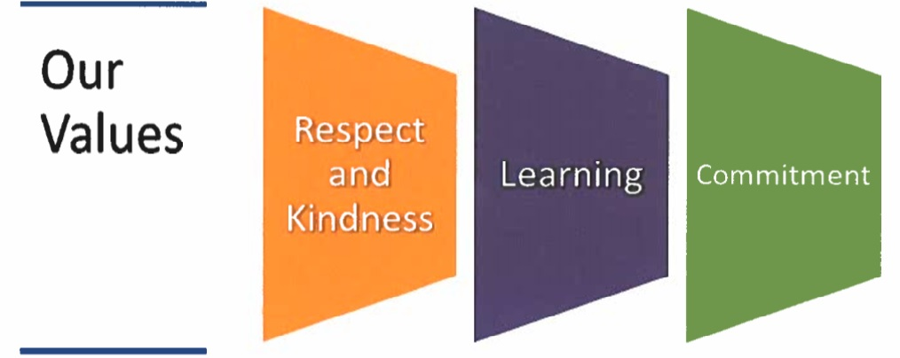

Fundamentally, we believe that the key to successful behaviour management is building strong working relationships with the students we teach, based on mutual respect and trust.

Of our students, we have three basic expectations:
- Follow the instructions of all members of staff;
- Be polite and courteous to all members of staff and to each other;
- Respect the school building and the resources available in it.

We should promote these expectations as much as we can with students and parents. Where student behaviour falls short of these expectations, rightly, there are consequences. The next part of this document outlines procedures around these.

General Principles for Behaviour Management:

Quality relationships are important

Students need to know that teachers care about them and their learning. Creating a culture of learning is not an exact science but it is important that teachers work hard on this aspect. Strategies that help are as follows;
- Taking a genuine interest in students and their lives as allowed by the curriculum
- Meeting pupils at the door at the start of every lesson has proven to be an effective strategy in managing positive relationships and behaviour.
- Ensuring that students are praised when they make genuine efforts in class (when overdone, too much praise can be counter-productive)
- Ensure that supportive, restorative discussions are a key part of any response to poor behaviour. It’s about the young person choosing to put their learning and others’ learning first and making good choices.
- Being really clear about expectations and having high standards about the quality of work produced.
- Effective time for questioning and discussion allows pupils’ voices to be heard and pupils’ thoughts understood in the context of their learning.
- Involvement in the wider life of the school helps in this regard.

Praising pupils

Praise and positive feedback are very important to student motivation and learning. Both should be an integral part of the day-to-day school experience for students.

House Points can be awarded for positive actions by a student in any setting.

We use Well Done Postcards to recognise excellent student effort or achievement:
- All faculties should have clear criteria for their use;
- All teachers should be issuing these.

Collaborative Approach

We work as a team to reinforce expectations and promote positive relationships and behaviour. At every stage there is an expectation that help is available – through discussion, sharing of strategies, being around to help and more robust supportive interventions if required. Teachers take responsibility for the relationships in their own class, but should seek this help if issues are becoming persistent or difficult to manage.

Staged Intervention

Eyemouth High School operates a policy of staged intervention. An important principle is that issues should usually be dealt with at as low a level as possible, being referred upwards in a staged way, as illustrated:
Headteacher
Teacher, Additional Needs Assistant

Depute Headteacher
(i.e. Senior Manager)

Principal Teacher
(i.e. Middle Manager)

It is important to understand that, as a general rule (but of course there will sometimes be exceptions), this model applies at all times during the school day, whether during timetabled classes, at transitions between classes, or during breaks. If an ANA has an issue with a young person, immediate assistance should be sought from the class teacher, or the PT Additional Needs or SLT if an incident out of class.

A fresh start!

Conversations about expectations are important. If a pupil has fallen short of expectations they need to opportunity to put things right, and may also need further support. We need to be clear that managing pupil behaviour is part of our work, that we wish students to get things right, and that we can put behind us issues from the past and make a fresh start. Speaking to pupils through this at every stage will be key.

Uninterrupted learning is our expectation; we and our pupils are entitled to it.

High quality learning is at the heart of what we want to achieve as a school – protecting time for this is important. Students prefer lessons where they can make progress and learn effectively – insisting on quiet when the teacher or others are talking to the class is important, for example. Students need to understand the different ways that talk is allowed in the classroom and how to manage themselves so that learning can always be taking place. When dealing with pupils the interruption of learning is at the heart of constructive conversations which aim to focus on being ready to learn and enabling others to have the opportunity to learn. We will focus on three simple expectations for students:
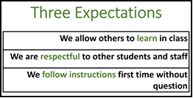

Professional Reading on Behaviour Management

Lee Canter has produced some very good work on the areas of promoting positive behaviour and assertive disciple. An internet search of his name (or of “positive behaviour management” or “assertive discipline”) brings up a variety of articles and YouTube clips which should serve as a useful starting point to any member of staff who wishes to explore this topic further.

Tom Sherrington & Oliver Caviglioni have produced a very accessible book,’Teaching Walkthru’s’, which provides concise, research based advice on positive approaches to behaviour management among other things.

Tom Bennett’s work is also very readable and his latest book ‘Running the Room’ and provides a common sense approach to behaviour management for those looking for a more detailed analysis.

Consistent joint approaches will help

Please see the following charts overleaf and note the following:
- These charts are illustrative – they will not cover every aspect of student behaviour.
- We will use just one category for the demerit – ‘disruption to learning.’ Once in the system demerits can be tracked and individuals identified who may need further support. The ‘splat’ can be found in the top-right corner of the class register.
- Communication within faculties is good about students. When an issue becomes ‘persistent and ongoing’ then the PT can initiate a referral to the appropriate person – this could be Pastoral or SLT – to start with the referral can be ‘For Information’ to inform about what has been done. Later the referral can ask for further action if the situation is ongoing.
- Informing parents may be appropriate at every stage, depending on the pupil. Sometimes a quick call home can pay dividends back in class.

Detentions

Each department or faculty may wish to run detentions of one form or another. This could be staying with a class teacher at break or part of lunch, or organising this across the faculty. On a whole school level, we will ask for volunteers to staff a BGE lunchtime detention and a Senior lunchtime detention on a weekly basis. SLT will run twice-weekly after school detentions as well. The admin staff will ensure that records are kept, letters are sent, and information communicated to those involved. SLT will monitor attendance.

Situations which require direct immediate intervention by a PT or SLT

- Where there is physical violence in a classroom.
- Where there is swearing at a pupil or adult with aggression – this requires some judgement. All incidents of swearing need to be addressed, however staff must judge whether this has an aggressive aspect to it.
- An incident of vandalism.
- Generally if a member of staff feels unsafe in the classroom, help should be sought immediately. This can be done via a phone call, or in immediate and urgent need, the panic alarm can be pressed.

Monitoring

Use of the Demerit system means that we can monitor how our pupils are doing across a range of subjects and experiences in school.

In particular we can monitor:
- Incidents of disruption to learning – using demerits
- The use of referrals by PTs and the progress of each referral in the system

Both of these are accessed through the class register with the Star and Splodge icons respectively. They can be added in bulk via an admin account and the school office.

In general terms, monitoring should be part of our normal, everyday activity.

Who is monitoring? | What are they monitoring? How often?
Admin Staff | Ensure that everyone is able to access the system in order to record demerits or referrals.
Class Teacher | Class teachers should monitor on a lesson by lesson basis. Where a pattern of poor behaviour is formed, the class teacher should apply the policy and discuss with their PT.
Principal Teacher | PTs will monitor through their weekly DMs or by discussion with individuals, any ongoing and persistent issues brought to their attention.
PT Equity | Will monitor the award of demerits, praise postcards and referrals for young people affected by PEF.
PT Pastoral | Will monitor demerits and referrals for young people in their caseload. For discussion in house meetings on a weekly basis.
SLT | Will monitor on a half-termly basis demerits across the school, by faculty, pupils and teacher to ensure follow-up and consistency in application.

Communication

We will use the following means to communicate about this policy:
- The school website
- In registration and assembly
- Through posters and information around school
- With posters of our expectations, which can be used to refer to
- Through the parent council
- Through school newsletters
Other supportive approaches which may be accessed are as follows:

Professional Reading on Behaviour Management
Lee Canter has produced some very good work on the areas of promoting positive behaviour and assertive disciple. An internet search of his name (or of “positive behaviour management” or “assertive discipline”) brings up a variety of articles and YouTube clips which should serve as a useful starting point to any member of staff who wishes to explore this topic further.

