National 5 Admin & IT
Administration is a growing sector which cuts across the entire economy and offers wide-ranging employment opportunities. Moreover, administrative and IT skills have extensive application not only in employment but also in other walks of life.
The key purpose of this Course is to develop your administrative and IT skills and, ultimately, to enable you to contribute to the effective functioning of organisations in administrative positions. The Course aims to enable you to:
- develop an understanding of administration in the workplace and key legislation affecting both organisations and employees
- develop an understanding of good customer care and its benefits to organisations
- develop IT skills and use them to perform administrative tasks
- acquire organisational skills in the context of organising and supporting events

Course Content
Topic | Learning Outcomes
Administration Theory in the Workplace | - Tasks (duties) of administrators, eg:  — creating and updating spreadsheets, databases, presentations, word-processing and desktop publishing documents  — booking meeting rooms and venues  — organising travel and accommodation arrangements  — organising and storing files in the correct order  - Skills/qualities of administrators, eg:  — organised  — good communicator  — team player  — co-operative  — willing to learn or develop  — ability to multitask  — ability to follow instructions  — good IT skills  — patient  — tactful/discreet  — approachable
Customer Service | - Key features of good customer service, eg:  —using customer feedback forms  —providing all staff with a customer service policy statement  —ensuring all staff know the products and services offered to customers  —ensuring all customer queries and problems are dealt with quickly and politely  —monitoring staff performance  —hiring suitable, friendly and helpful staff  —setting and evaluating staff targets  —ensuring staff follow complaints procedures  - Benefits of good customer service, eg:  — customer loyalty  — reduced complaints  — increased profits/sales/decreased costs  — good publicity  — lower staff turnover/less absenteeism  — competitive edge, therefore increased market share  — improved efficiency/increased productivity  — reduced waste  - Consequences of poor customer service, eg:  — increased customer complaints  — decreased profits/sales/increased costs  — negative publicity  — higher staff turnover/higher absenteeism  — decreased market share/fewer customers  — lower efficiency/decreased productivity  — increased waste
Health and Safety | - Features of current legislation:  — features of current health and safety regulations/legislation — The Health and Safety at Work etc Act 1974 (HASAWA), fire safety, Display Screen Equipment (DSE), first aid and workplace regulations  - Key organisational responsibilities in terms of health and safety, eg:  — use of induction training to cover health and safety issues  — understanding what employers must do to observe health and safety rules, in accordance with current legislation  — identification of hazards in the workplace and measures to ensure safe practice, eg completing an accident report form
Security of People, Property and Information | - Key organisational responsibilities in terms of security of people, eg installing secure entry systems  - Key organisational responsibilities in terms of security of property, eg applying security marking  - Key organisational responsibilities in terms of security of information, eg issuing usernames and passwords  - Features of current legislation, eg data protection, computer misuse and copyright
Sources of Information from Internet | - Features of reliable sources of internet information, eg:  — non-biased  — complete/sufficient  — accurate  — regularly updated site  — reputation of author  - Benefits of using reliable internet sources of information, eg:  — good decisions can be made  — organisation gets a good reputation  — organisation gains opportunities  - Consequences of using unreliable internet sources of information, eg:  — missed meetings  — wrong decisions are made  — organisation gets a bad reputation  — organisation loses money  — organisation loses opportunities
File Management | - Features of file management, eg:  — appropriately named files and folders  — archiving/dead filing  — regular backup  — regular antivirus updates  — security on files  - Benefits of good file management, eg:  — saves time finding files  — saves space on network  — less stress for employees looking for files  — improved efficiency leads to a good reputation  — no duplication means that files are more likely to be up to date  - Consequences of poor file management, eg:  — wastes time finding files  — wastes space on network  — more stress for employees looking for files  — lower efficiency, leading to a poor reputation  — duplication, meaning files are less likely to be up to date
Corporate Image | - Features of corporate image, eg:  — standardised colours, fonts, graphics  — logo  — slogan  — staff uniform  — store layout  — standardised responses to frequently asked questions (FAQ)  — standardised customer service  — consistent presentation of IT documents using a house style  - Benefits of having a corporate image, eg:  — instantly recognisable brand  — more professional reputation  — staff are more consistent, so that customers are dealt with fairly  - Consequences of no/negative corporate image:  — no recognisable brand  — less professional reputation  — staff are less consistent, so that customers are not dealt with fairly
Electronic Communication | - Methods, features, uses and benefits, eg:  — blog  — e-diary  — e-mail  — podcasts/vodcasts  — presentation  — social media  — video and audio conferencing  — webinar  — website
Word Processing and/or Desktop Publishing (DTP) | - Creating and editing a range of documents, complying consistently with house style which may contain multiple pages, eg:  — letters (eg application, thank you and enquiry)  — business reports  — forms (eg travel forms and booking forms)  — minutes  — agendas  — itineraries  — posters  — booklets  — newsletters  — name badges  - Using a variety of word-processing and desktop publishing skills, eg:  — text formatting  — page formatting  — using templates  — select and/or change font and font size  — set and change margins and line spacing  — insert, delete and move text  — find and replace text  — cut and/or copy and paste  — carry out manuscript corrections  — enhance text, eg bold, italics and underline  — align text  — insert graphics  — bullets and numbering  — insert headers and footers, both manual and custom  — borders and shading  — page numbering  - Creating and enhancing a table, eg:  — insert, delete or amend data  — add or delete row(s) and column(s)  — borders and shading  — merge cells  — alignment of data, eg centre within cell, text direction  — formulae (sum only)  — sort data on one or two columns  - Importing data from IT applications into a document, eg:  — data and/or chart from a spreadsheet file  — data from a database file  — data from a word-processing/DTP file  — information from the internet  - Merging appropriate data from spreadsheet and database applications into a business document, eg:  — labels  — letters  — reports  — name badges  — forms  — certificates  - Using comments, eg:  — add  — action  — delete  - Printing documents and extracts of documents, eg:  — completed document in different layouts (such as, A4 and A5)  — document showing merge fields  — specific pages
Spreadsheets | - Creating, editing and formatting a workbook, eg:  — inserting and deleting rows/columns  — hiding rows/columns  — alignment of data, eg centre within cell, text direction  — different fonts, styles, and sizes  — currency, number, percentage to specified decimal places  — date format  — borders and shading  - Applying advanced functions and formulae to a workbook, eg:  — +/−/÷/× individually or combined  — sum  — average  — maximum  — minimum  — count and counta  — if  — link cells within worksheets  — use named cells  — relative and absolute cell references  — sort data vertically on one or two columns  - Using comments, eg:  — add  — action  — delete  - Creating a chart and labelling it independently, using data from adjacent and non-adjacent columns and rows, eg:  — pie chart  — bar or column chart  — line graph  - Labelling charts meaningfully, eg:  — chart title  — axis labels  — data labels  — legend  - Printing worksheets and extracts of worksheets:  — showing value view  — showing formulae view  — with and without gridlines  — with and without row and column headings  — in portrait and landscape orientation  — with headers and/or footers, both manual and custom  — to fit on one page  - Printing charts:  — embedded in worksheets or presented separately  — with identifiable labels either by colour labelling or patterns (when using black and white charts)
Databases | - Creating forms:  — using selected fields from one or both tables, or a search  — with a header and/or footer using text and/or graphics  - Creating and presenting information in reports to a professional standard:  — using selected fields from one or both tables, or a search  — with a header and/or footer using text and/or graphics  - Creating labels:  — from a table or search  — with header and/or footer  - Editing a relational database:  — inputting and editing data in tables or making using of forms  — altering date format and decimal places  — adding and deleting field(s) and record(s)  - Searching information in a relational database using the following operators:  — equals  — greater than  — less than  — greater than or equal to  — less than or equal to  — or  — not  - Sorting information in a relational database on one or two fields  - Printing:  — tables, search results, specified fields, forms, reports and labels, to fit on one page
Presentations | - Using functions of multimedia applications to create and edit presentations, eg:  — insert, delete and edit text  — format text  — insert and delete a graphic  — bullets and numbers  — create charts and/or tables  — add and delete a slide  — animate text and/or objects  — import data  — change slide layout  — apply slide transitions  — change slide order  — apply and change background, colour scheme and/or apply design templates  — insert footer on slides and handout  — insert and delete action buttons  — insert slide and page numbers  — insert both specific and automatic date  — use slide master  - Printing presentations in different formats, eg:  — slide  —handout
Electronic Communication | - Searching for, extracting and downloading relevant information from the internet and intranet:  — opening browser  — using search engines  — navigating hyperlinks  — copying information from a web page to a word- processing/DTP document and presentation  — using favourites/bookmarks  — printing information and/or an extract of information  - Using e-mail:  — composing e-mail by entering text and sending to one or more recipients  — using the address book facility  — marking urgent  — using cc  — using reply  — using forward  — adding attachment(s)  — creating signature  - Using an e-diary, eg:  — schedule appointment  — set reminder  — print calendar: daily, weekly and monthly view  — schedule recurring appointments  — accessing other users’ calendars  —schedule tasks

Assessment of the Course
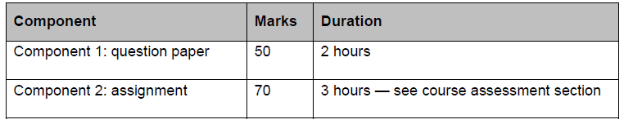

Question Paper
Practical paper carried out on the computer in 2 hours and is made up of:
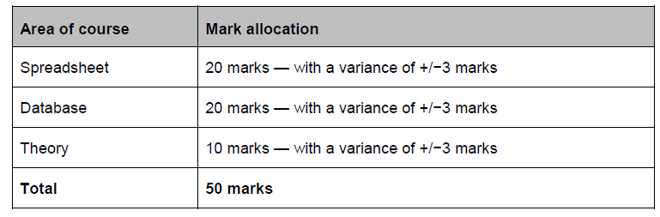

Assignment
Practical assignment carried out on the computer (closed book) in 3 hours and is made up of:


