Advanced Higher Business Management


Student Induction Pack

1. PURPOSE AND AIMS OF THE COURSE
A vibrant and innovative business culture is a vital component of Scotland’s economic success. The purpose of this Course is to prepare you to play an active part in this culture by equipping you with an understanding of the national and global nature of business. This will include the challenges posed by globalisation and the effect it has on Scotland’s businesses and environment, business and management theories, and principles of effective management used in different organisations. You will develop analytical and research skills by investigating real organisations in a range of contexts.

The Course aims to enable you to:
- Enhance the skills of independent learning, research, critical analysis and problem solving in a business context
- Apply business and management concepts and theories to reach conclusions
- Evaluate the social, ethical and global factors that affect local, national and multinational organisations
- Analyse and evaluate leadership theories, management schools of thought and approaches to managing change
- Prepare and critically evaluate a range of analytical techniques and management techniques used to assist in effective planning and decision-making at a strategic level

The study of business management provides you with a perspective that gives you the ability to research, analyse and interpret the actions and decisions taken by real organisations and to explain how these actions and decisions might affect businesses and their economic success.

The contexts of study are complex and challenging, particularly in terms of the application of business concepts and management theories to current business situations. Undertaking this Course will require a more sophisticated level of communication skills, as you are required to interpret complex business information, to discuss current business issues and to present logical and reasoned explanations and discussions related to these issues.

Development of research and investigative skills is a key focus of this Course. These skills encourage independent learning and the use of initiative, and also provide opportunities for team working. The Course gives you an in-depth understanding of the global nature of business, the internal and external factors that affect business success, and how large organisations are managed and react to change.

Advanced Higher Business Management is, therefore, instrumental in developing your higher-order thinking skills. It provides an in-depth knowledge and understanding of the managerial theories and aims that underpin the actions taken and decisions made by large organisations.

2. COURSE STRUCTURE
The Course has three mandatory Units. By its nature, the Course develops a wide range of transferrable skills for learning, life and work by providing you with the opportunities for active learning in studying current business contexts.

- The External Business Environment
You will develop a detailed knowledge and in-depth understanding of the effects of external influences on organisations operating at a multinational and global level. The Unit provides you with the opportunities to investigate how an organisation is affected by external factors and to gain an in-depth understanding of the responsibilities of managers in an economic, social and environmental context. You will analyse and evaluate the impact of such external factors and consider the effectiveness of various courses of action.

- The Internal Business Environment
You will gain a thorough grounding in the discipline that forms the basis of management practice. The Unit allows you to carry out activities that will expand your knowledge of both traditional and contemporary management theories used by organisations to maximise their efficiency. It also allows you to analyse and evaluate theories relating to internal factors that influence the success of teams.

- Evaluating Business Information (Advanced Higher)
You will develop skills in evaluating a range of business information used by organisations to reach conclusions. This will help you to become competent and confident in the analysis and evaluation of business information, based on a research project carried out on a topic from the Course.

3. Course Content
The External Business Environment
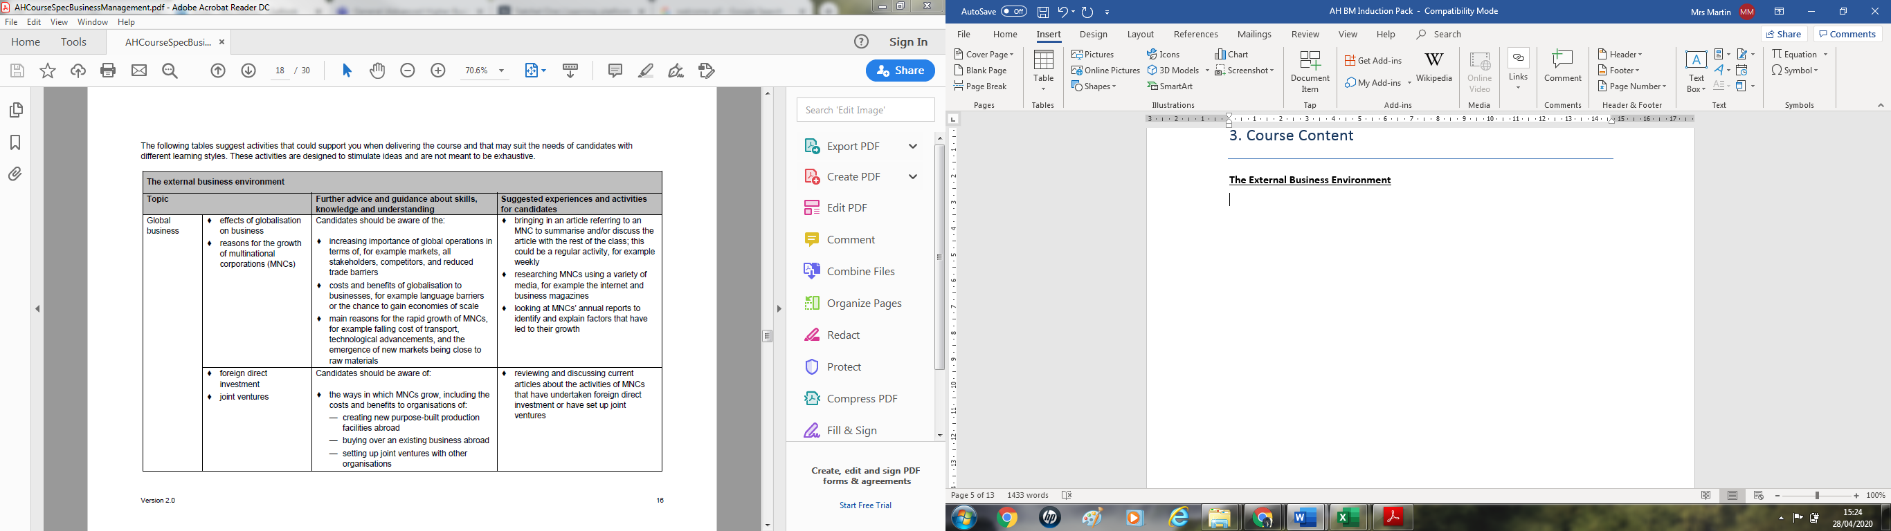
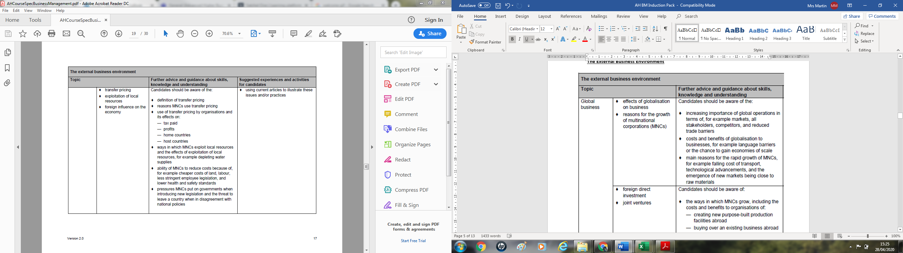
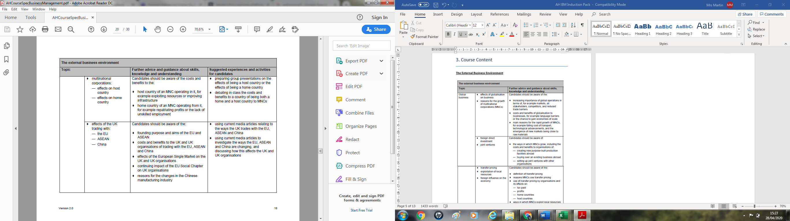
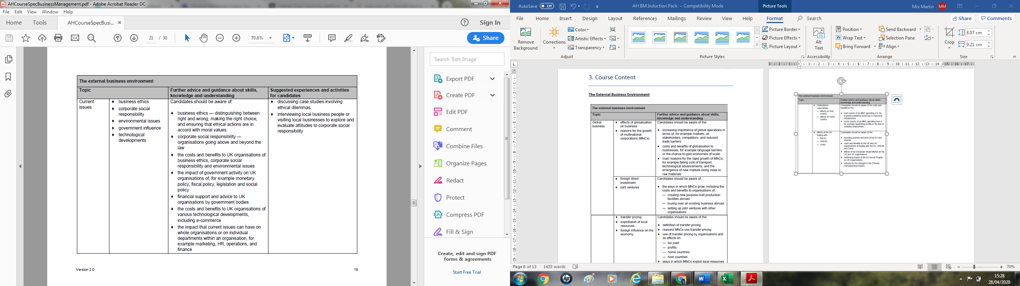

The Internal Business Environment
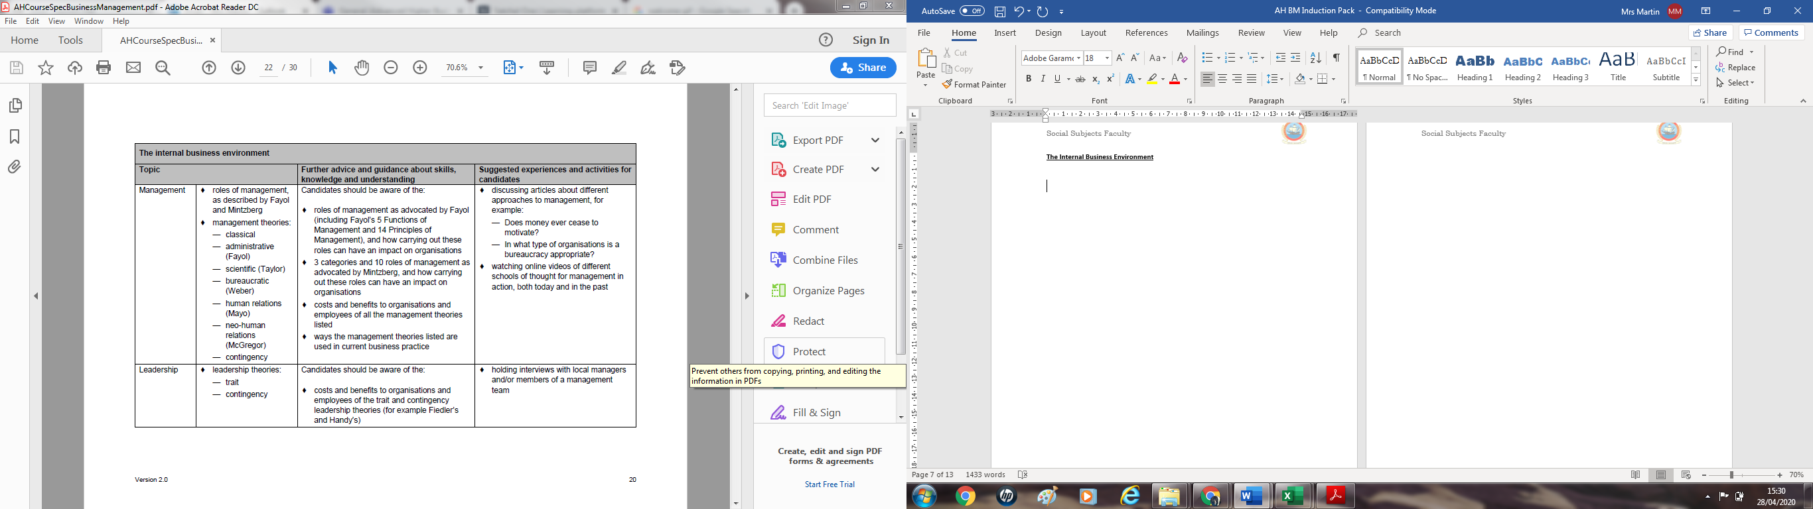
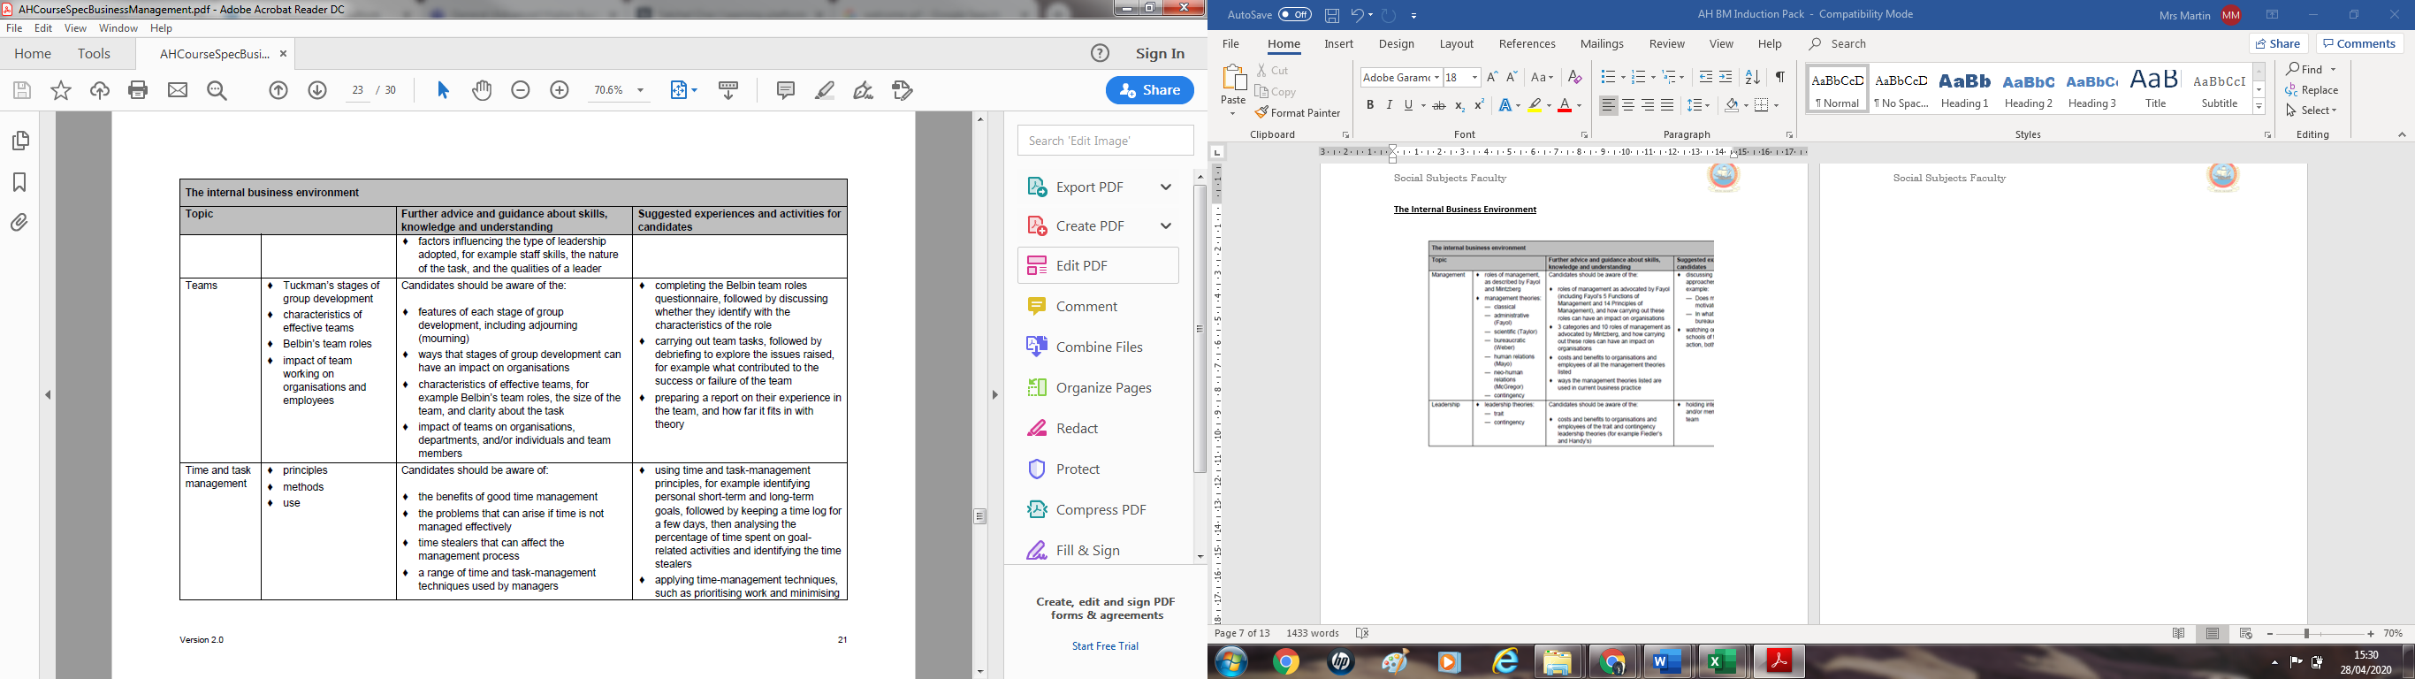

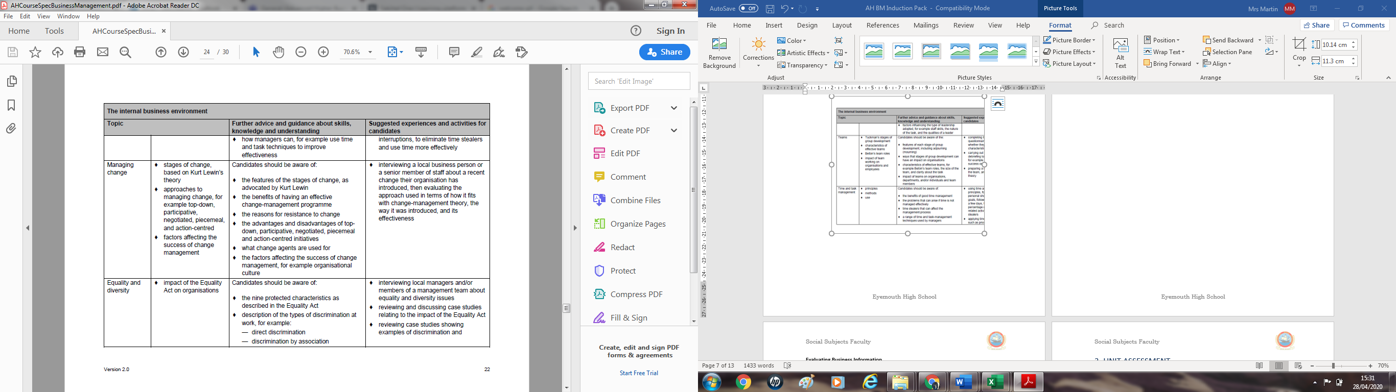
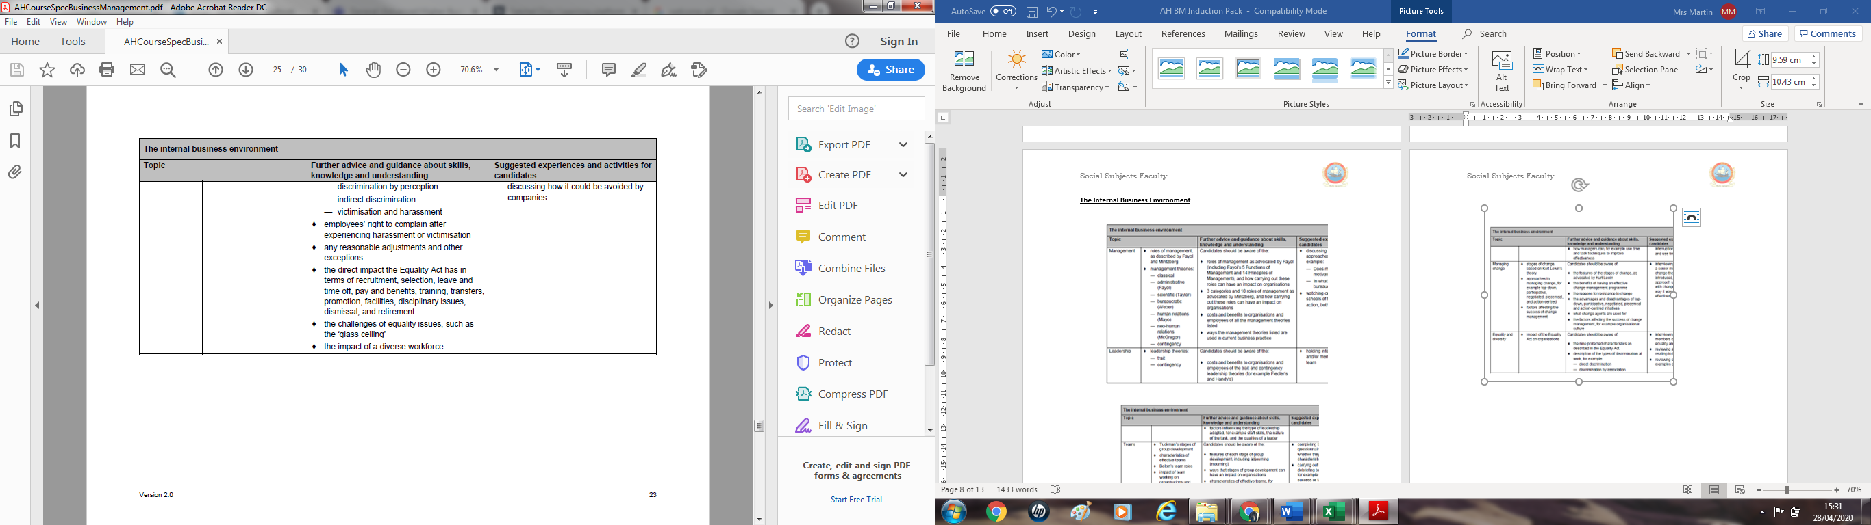
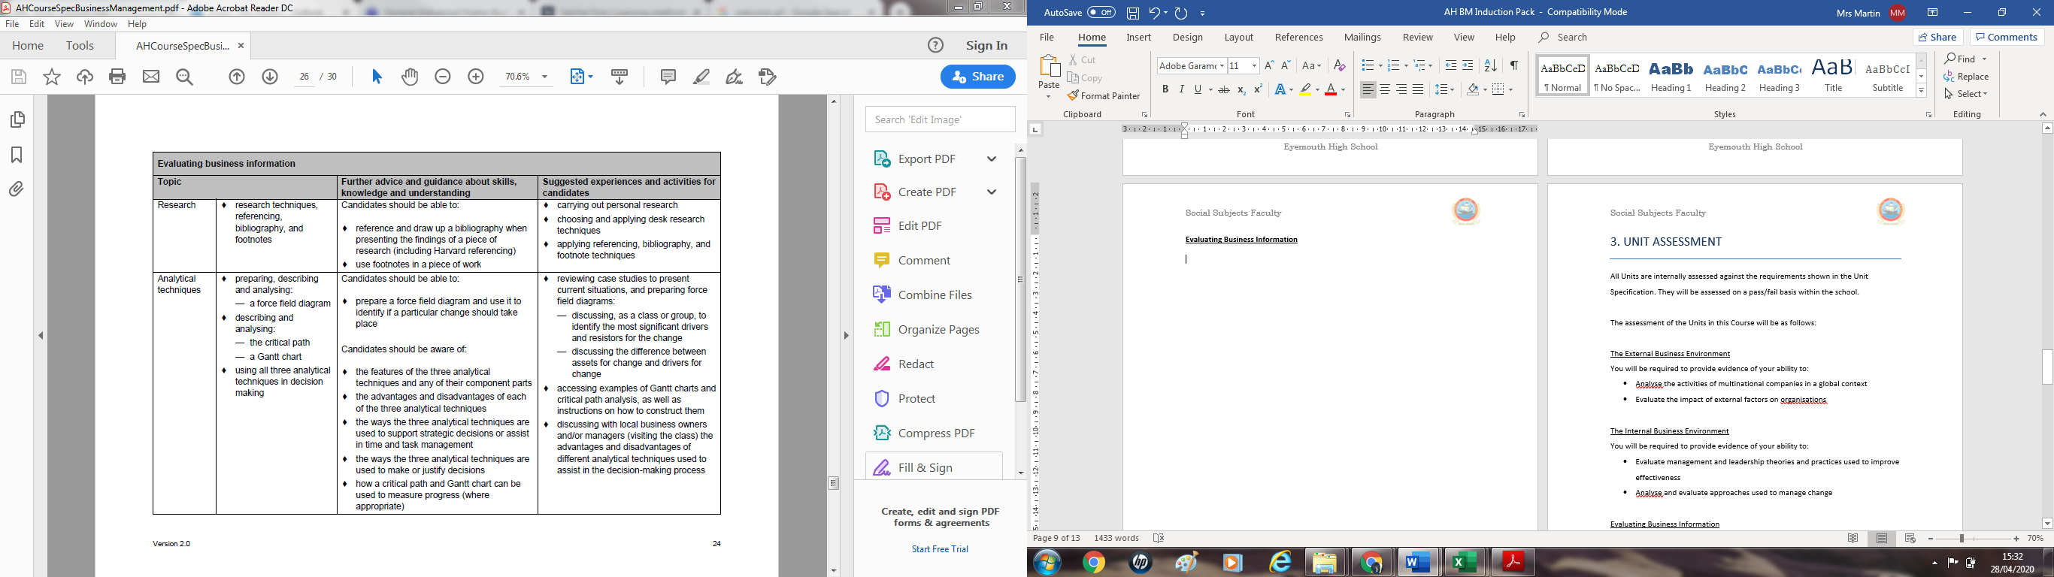
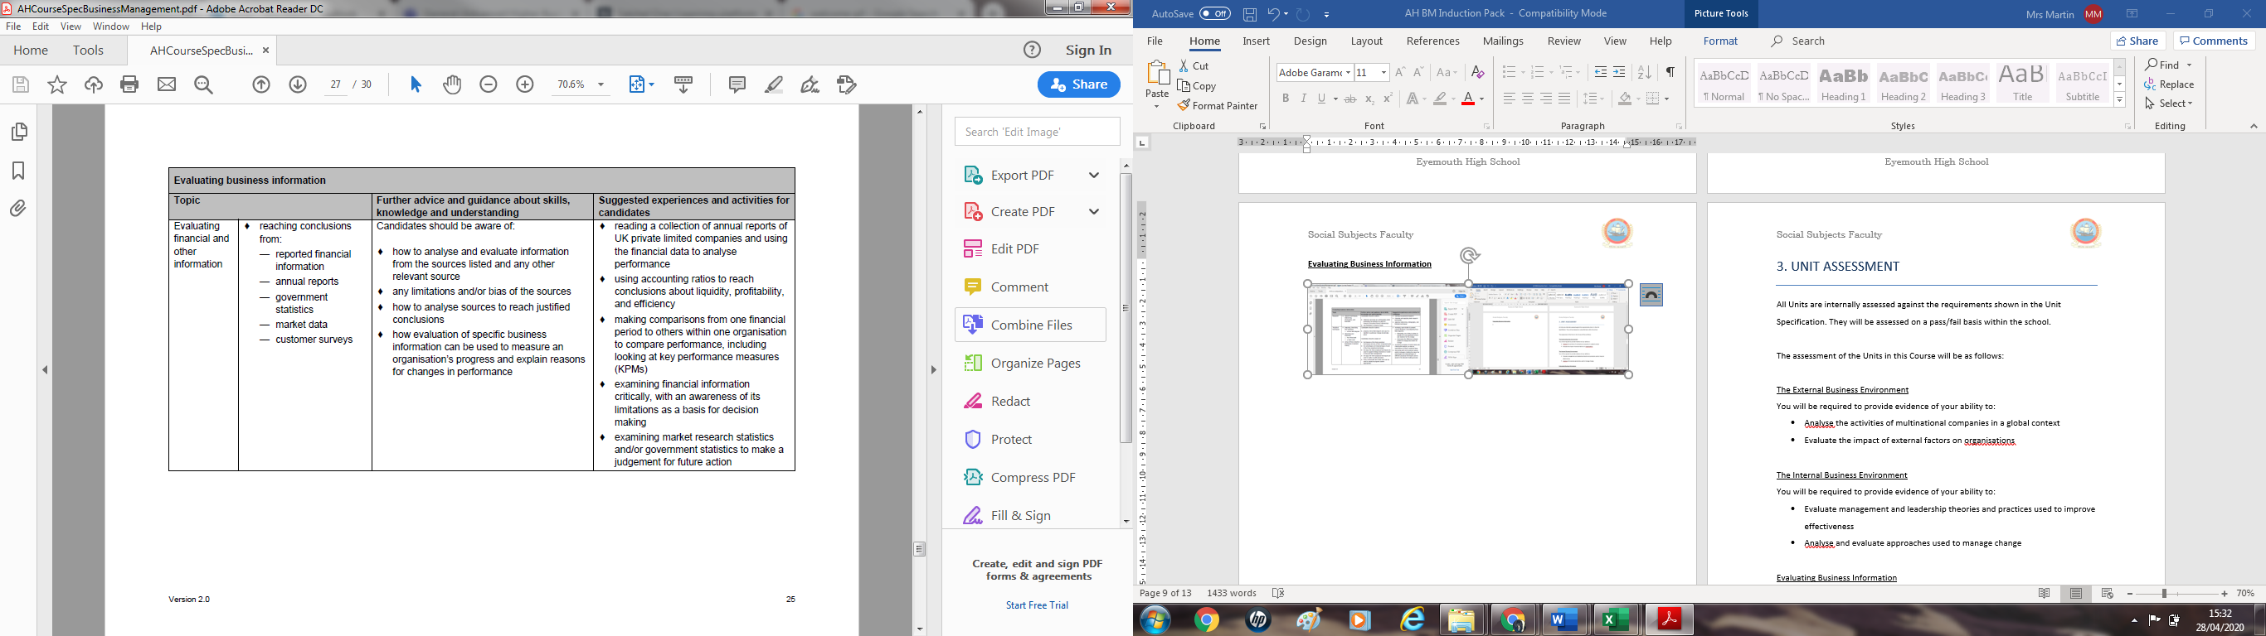
Evaluating Business Information

3. COURSE ASSESSMENT
This will be assessed through a Business Management question paper (80 marks worth 67% of the overall marks for the course) and project (40 marks worth 33% of the overall marks for the course).

Question paper
The purpose of this question paper is to address challenge and application. These will be assessed by drawing on, and sampling, the knowledge and understanding from across the Course. Learners will be required to apply their knowledge and understanding of business concepts and situations in complex contexts.

The question paper will give you an opportunity to demonstrate the following skills, knowledge and understanding by:
- Analysing complex business information to evaluate strategic plans and strategic decisions of large organisations, and the impact of external factors on large organisations
- Applying knowledge and understanding of complex business, management and leadership theories and concepts to specific business situations
- Evaluating the social and ethical impact of multinational companies at home and abroad
- Evaluating how analytical techniques and emerging technology can be used to support business decisions
- Communicating complex business ideas and opinions with clarity and logic

This question paper has two Sections.

- Section 1 will have 40 marks and will consist of a set of mandatory questions based on a business case study stimulus. The questions will be drawn from across the Course. You will be required to demonstrate application of skills and knowledge and understanding, within the context of the case study.

- Section 2 will have 40 marks and will consist of four mandatory questions, worth 10 marks each, which are drawn from across the Course.

Project
The purpose of this project is to address challenge and application. The project will provide you with the opportunity to apply and extend research, analytical, evaluative and decision-making skills, within the context of a business topic or issue.

You should use a wide range of business sources relevant to the context of the project, and present your findings in a business report.

This project will give you an opportunity to demonstrate your ability to:

- identify an appropriate organisation or industry
- select a topic from the course coverage
- gather research from a range of sources
- apply knowledge and understanding of business concepts to explain, analyse, and evaluate the topic
- reach valid conclusions and/or make recommendations based on evidence
- structure a detailed, well-informed report based on the topic and organisation(s) or industry
- organise, present, and reference findings using appropriate conventions

The project has a total mark allocation of 40 marks. This is 33% of the overall marks for the course assessment. Marks are awarded for:
- introduction 5 marks
- analysis and evaluation 20 marks
- conclusions and recommendations 8 marks
- Research 3 marks
- structure and referencing 4 marks

4. SOURCES OF INFORMATION
Textbooks
Business Studies (4th Edition) (Hall, Jones & Raffo) 9781405892315 CP
Past papers
Past Papers will be supplied, but will are also available on the SQA website.
Other Resources :
http://beta.tutor2u.net/business – has lots of revision presentations and a blog of current news stories
Business Studies - Free Revision Notes for all Students of Business studies revision notes for AS, A2 and GCSE Business Studies. www.business-studies.co.uk

It is important that you keep up with events in the business world and you should regularly listen to or watch news bulletins.

