Countdown to Christmas Special!
f

EYEMOUTH HIGH SCHOOL | PARENT BULLETIN
1st December | 2022 |

CHRISTMAS IS COMING!
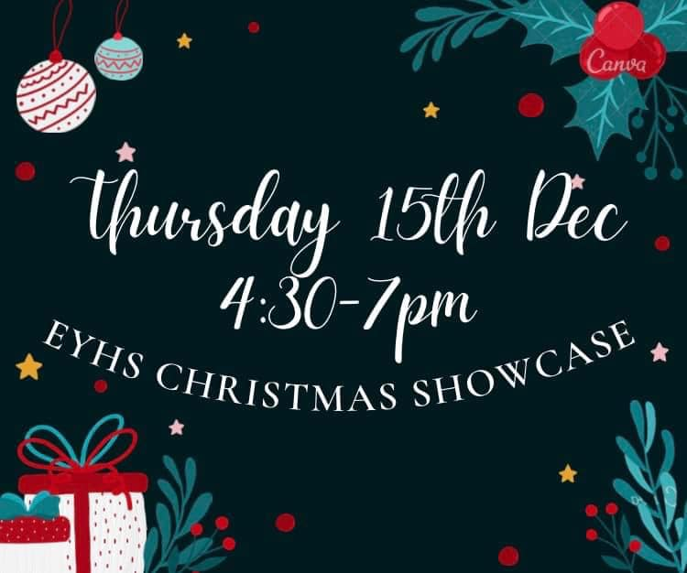
We hope you have enjoyed the St Andrew’s holiday this year. We have been very busy this term so far, and for the first time in a long time have a full programme of Christmas events planned. Our Christmas Showcase is back – bigger and better than ever, and a time to come and see everything that the school and local partners are up to. We are blessed with such a fantastic community where sports, volunteering and so many activities are going on. We will have performances on the night, refreshments in two ‘cafes’, arts and crafts, curriculum displays and lots of community involvement. It is a great evening – starts at 4:30pm and we will wrap up by 7:00pm. Alongside all of the free activities, there are raffles, games, prizes and small items to buy, so please bring some cash with you if you wish to take part.

We are also looking forward to our Christmas Dances – our Junior Dance is the 19th December, and the Senior Dance is on Wednesday 21st December. Pupils have been preparing hard for these in their PE lessons – learning all the dances so that they can have a great time together!

“We are blessed with such a fantastic community where sports, volunteering and so many activities are going on...”

Activities this term…so far!
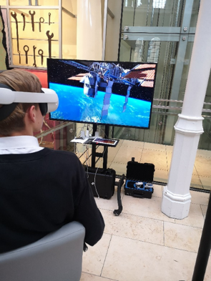
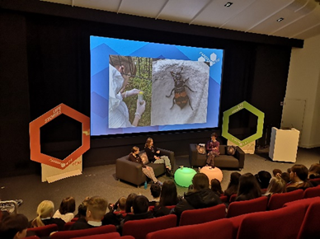
There have been plenty of opportunities for our young people to learn in and out of school. On the left are pictures from the S3 STEM event at the National Museum. Underneath from the our very successful successful Careers Afternoon – this was the wider uniformed services afternoon!

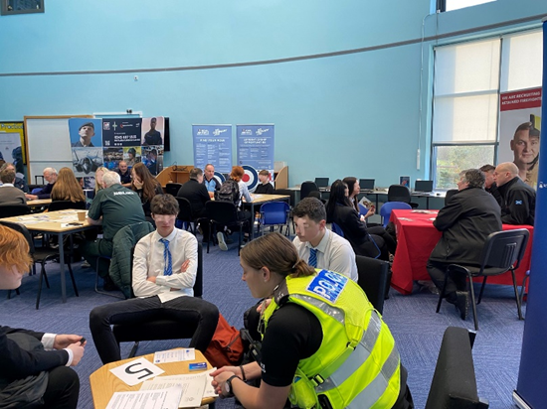

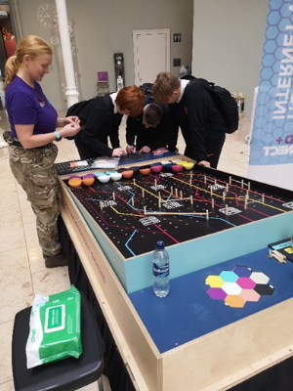
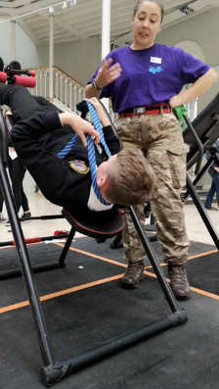
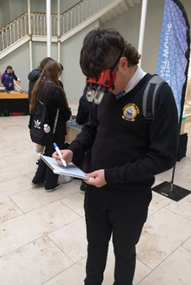

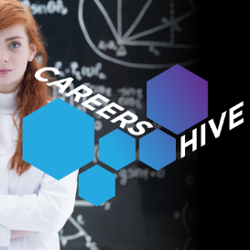 |  |  | On Monday 7th November all S3 students were invited to attend the Edinburgh Science Festival Careers Hive event at the National Museum in Edinburgh to learn about careers in STEM subjects. The day started with a talk from scientists about their career journeys including how insects can be used in forensic science and the work of Young STEM leaders from across the world.  In the afternoon students explored how their skills could be applied to STEM careers, and also had a chance to talk with a wide range of STEM professionals through taking part in activities. Some highlights included building an engine, VR space travel, keyhole surgery, upside down glasses, and programming robots! The event was fully funded by the Edinburgh International Science Festival who also found a sponsor (Edinburgh Construction) to cover costs of the bus travel.
 |  |  | Our series of Career Insight Afternoons for S4-6 ended on a high with Armed Forces and Emergency Services as well as Animal and Land Related Careers, with more than 50 pupils given the opportunity to find out about jobs they are interested in first hand from the professionals. We are very grateful to have been so well supported by our community in providing these valuable experiences for our pupils.
“You can find lots of information about the school on our School webpages”
 | Website: |  |  |  | Contact: |  |  |  | Email:
 | www.eyemouthhigh.org.uk |  |  |  | 018907 50363 |  |  |  | eyhs@scotborders.gov.uk

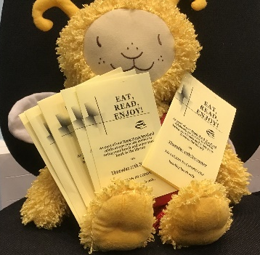

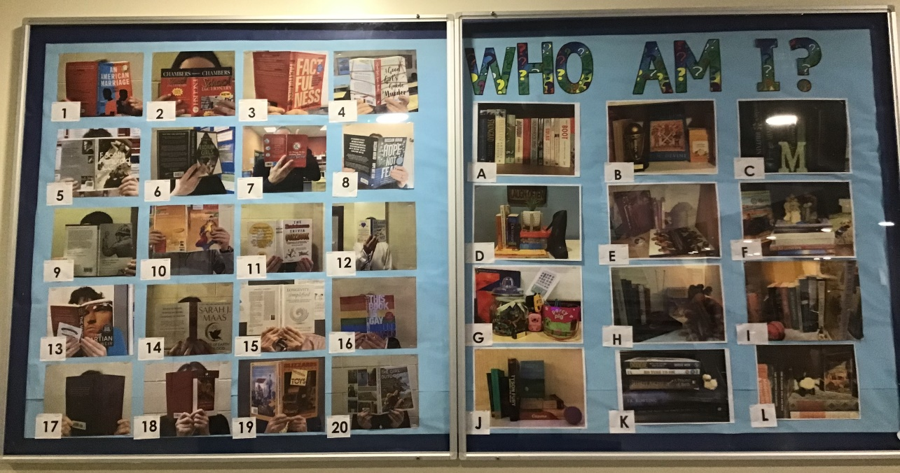
L iteracy Activities
TIE Workshops
Understanding Prejudice was the topic for workshops recently delivered by ‘Tie Scotland’. All students in S2 and S3 were given the opportunity to further develop their understanding of prejudice and the impact it can have on groups within society. Students were led through a scenario designed to challenge their perspective on how prejudicial views are formed. By exploring real-world examples, groups then discussed what they can do to challenge prejudice.

Book Week Scotland
Various events took place during ‘Book Week Scotland’ last month: Pupils were asked to ‘Guess the Shelfie’ and staff members behind the books; Readers were invited to ‘Eat, Read and Enjoy’ their book over lunch and during the week all S1 pupils enjoyed playing ‘The Reading Game’ and explored all genres of fiction.
Big thank you to our reading sponsors
Local companies have generously donated prizes and vouchers to promote and reward reading in S1 and S2. Because of these donations, over 75 pupils have passed a quiz on Accelerated reader in the past month. We want to thank the following companies for their continued support of the high school: St Vedas Surf Shop, Prime Property Ventures Ltd, Amey, Lough’s Bakery, Giacopazzis, CGI, VX2 Construction, Ahlstrom-Munkskjo, Simpson Malt Ltd, Rialto Café and Eyemouth Rib Trips. We really do appreciate the support of our local community.

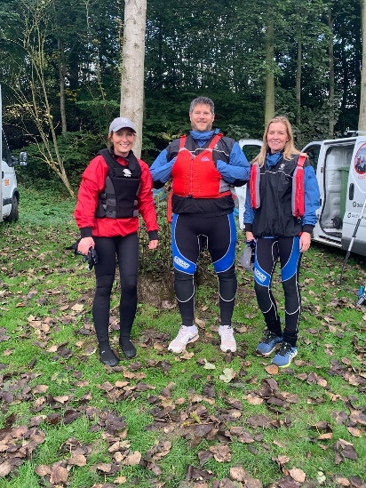
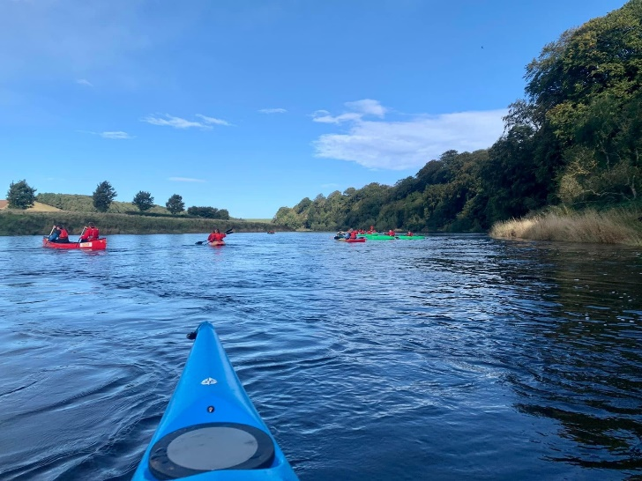
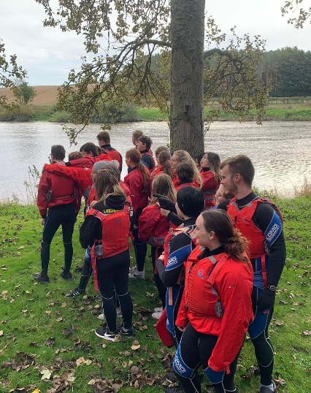
S6 Paddle Party!

Our S6 year group kicked off the half term holidays with an adventure day. We had a very sunny day on the Tweed paddling in various water craft from Norham to Paxton House. There was much laughter (and singing!) amongst a lot of water fun. We even enjoyed lunch on an island. Most managed to stay in their boats although hilariously Mr Mackenzie had to demonstrate his love of swimming by capsizing no less than 3 times! We’d like to thank Adventure Northumberland who are based at Paxton House and gave us a wonderful day of memories!

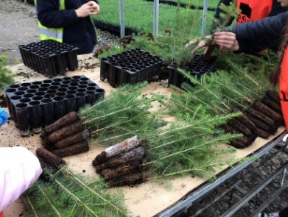
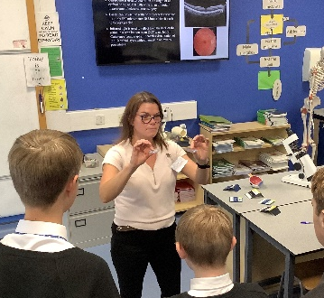
Science experiences
Cheviot Trees hosted our Horticulture students in SS,4,5 and 6 for an afternoon. They toured the local site and found out about all aspects of the business – the planning, the sowing of seeds, use of new technology, quality assurance and tehir ongoing research. This may lead to more opportunities for individuals and groups in the future – a brilliant visit!
Julie Campbell (mum to Anna, one of our S3 Physics pupils) gave a talk to all of our S3 Physics students. Julie is an ophthalmologist and spoke about how physics helps determine a patient's refractive error (during an eye examination), how different index lenses are used to correct their vision, and cosmetic and practical applications of different materials and coatings.

