School Improvement Plan
2024-25
Eyemouth High School
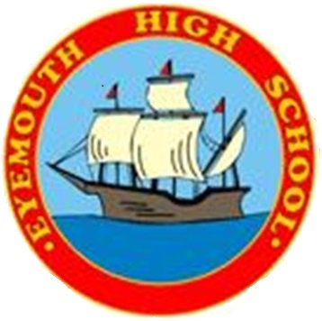

INTRODUCTION - School Improvement Planning 2024/25

This document outlines our identified priorities for Session 2023/24, which will bring about continuous improvement of outcomes for our learners. It is based on rigorous self-evaluation of our provision, including the impact of development work carried out during 2022/23. For more information on our performance, see our School Improvement Report 2022/23.

Self-Evaluation Summary
Identification of strengths and aspects for improvement involves knowing the impact of our work on learners.
Learners are at the heart of effective self-evaluation’ -HGIOS 4? HGIOELC?

Strengths 2023-24
- Our collaborative work in improving learning and teaching has led to consistent performance across the school. This is now embedded in our new Lesson Evaluation and Development toolkit. Our Instructional Coaching programme is underway and developing well for the new session.
- Our attainment at level 5 continues to go from strength to strength, with a new Flexible Curriculum team up and running to support attainment further.
- Our Health and Wellbeing approaches are contributing to our positive ethos and significant support for young people.
- Good evidence that our young people are thriving at school, excellent positive destination figures, significant learning through wider achievement, good attendance, integrated work-based learning, very good behaviour and strong supportive partnerships.

Areas for Improvement 2024-25
 | Short Term | Medium Term | Long Term
Learning, teaching and assessment (incl. pedagogy, pathways and digital) | Fully embed the use of our Toolkit across many different areas of professional dialogue and development in school. All staff are able to improve in chosen areas of practice. Establish trained instructional coaches across school. Level 6 results in S5 increasingly match Level 5 performance in S4. | Build on our culture of continuous self-improvement. Establish research-based instructional coaching as a key driver for improvement. Students leave school with improved results at level 4 and Level 6. Be confident in achieving Very Good for this element in an inspection. | Look for aspects of excellence in Learning and Teaching across the school. Staff are empowered to enhance their practice in a self-improving system. The school will be making a significant contribution across the local authority and beyond.
Inclusion (incl. nurturing practice, promotion of wellbeing and universal / targeted supports for all learners) | Parents have increased opportunities to be involved in pupils’ learning through our changes. Student HWB indicators are improving, through a focus on positive relationships and the pupil voice. We achieve the Silver RRS award. Our poverty-related attainment gap is decreasing due to these approaches. Our flexible curriculum enables key individuals to succeed. | Improved parental and pupil involvement is leading to better student achievement and opportunities, which are tracked and monitored. Pupils are effectively supported in their HWB and indicators show this clearly. We are working towards our Gold RRS award. Pupils affected by poverty are able to achieve in line with their peers. Targeted support is integrated with our flexible curriculum approaches. | We use data intelligently to inform key improvements in health and wellbeing led by pupils, staff and parents. This will help us achieve our Gold RRS award. Almost all pupils are fully engaged with in achievement activities and developing their skills and abilities. Pupils affected by poverty are well-supported by an enhanced multi-agency team to excellent outcomes.

Local authority priority: The #SBCway – a BREAKTHROUGH curriculum
QI |  | NIF Priority | SBC Framework | Intended outcome:  Learners across all schools and settings will benefit from a consistent Literacy, Numeracy and H&WB curriculum.  Attainment in Literacy, Numeracy and H&WB will increase.  All schools and settings will engage with the #SBCway STEM curriculum offer.
2.2, 2.3, 3.2 |  |  | LTA
Process |  |  |  |  |  | Progress Tracker
 |  |  |  | St. lead and key people | Timescale  (Date) | Measures of Success | Review Date
 | #SBCway BREAKTROUGH curriculum  What are we going to do?  - From August 2024, all schools and settings will implement the components of the new BREAKTHROUGH curriculum.  - Based on self-evaluation, clusters/schools will determine the order of implementation over a maximum of 2 years, agreeing how much time to allocate to each subject.  - Using the attached project plan, clusters/schools will ‘map out’ their implementation using the ‘Sprint’ approach.  - For each Sprint, clusters/schools will adopt the attached subject implementation plans. Each plan sets out the essential ‘ingredients’ of implementation. Based on self-evaluation, clusters/schools will identify which ‘ingredients’ they are missing. The final ‘recipe’ will provide schools with a clear improvement plan for the individual subject area.  - Clusters/schools will use the implementation plan and #SBCway Pedagogy Team content over the agreed Sprint period. |  |  | QIO  Cluster Leads  All HTs  Designated SLT  All School staff | Start = August 2024  Final deadline = August 2026  Implementation cycle = 10 sprints of 6 weeks  WTA hours set according to ‘Implementation plan’ ingredients | Outcome measures  By August 2026, all school and settings have implemented and are using the full #SBCway BREAKTHROUGH curriculum for Literacy, Numeracy and H&WB.  Reported pupil attainment for each subject area will support evidence of impact.  Audits of school / staff confidence for each subject area will support evidence of impact.  Process measures  Schools and settings will be able to evidence implementation of the 4-part curriculum:  - Methodology  - Pathways  - Assessment approaches  - Structure / Delivery  Clusters / schools will evidence action against the #SBCway ‘implementation plans’ for each curriculum subject; Listening & Talking, Reading, Writing, Numeracy & Maths, H&WB.  Clusters / schools will evidence action against the #SBCway STEM engagement plan. | Check-in 1  Oct 2024  Check-in 2  Dec 2025  Check-in 3  Feb 2025  Check-in 4  Apr 2025  Check-in 5  Jun 2025  Check-in 6  Oct 2025  Check-in 7  Dec 2025  Check-in 8  Feb 2026  Check-in 9  Apr 2026  Check-in 10  Jun 2026
Why we need to do it?
- To achieve equity and equality of educational offer and experience no matter the learning setting a child/young person attends.
- To raise attainment in Literacy and Numeracy by ensuring quality pedagogy.

School Improvement at Eyemouth High School

As a school we are adopting an agile-planning approach. Acknowledging that progress happens at all levels, the tools allow for collaborative and ongoing improvement with shorter improvement cycles, measuring impact and adapting plans. Our School Improvement Plan will reflect where we are starting this year, and we will adapt between cycles and update.
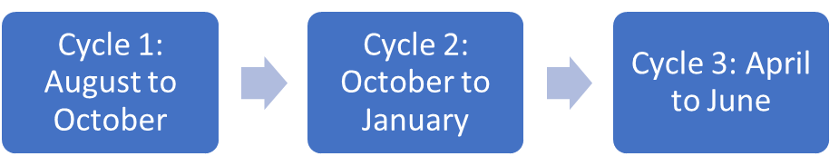
Agile Leadership Approach

QIs 1.1, 2.3 How we improve the student voice to impact on School Improvement? | QIs 1.2, 2.2, 2.7, 3.3 How can we improve further our work with our partners to enhance the curriculum? | QIs 2.1, 2.4, 3.2, 3.3 How can we hone our targeted and flexible curriculum approaches to provide maximum support for pupils at risk of achieving little?
QIs 2.3 How can we improve our Senior Tracking and Monitoring to being of an excellent standard? | QIs 1.5, 3.1, 3.2 How can we poverty-proof the school to provide equity for all pupils, closing the poverty-related attainment gap?
QIs 2.5, 3.2 How do we build opportunities for and record pupils’ achievements?

QIs 1.2, 1.3, 2.3, 3.2 How can we use the Agile planning tools alongside other data to effectively plan and deliver specific improvements in different subject areas around school?
QIs 1.2, 2.3, 3.1 How can we continuously enhance our policies and practices through our working groups around HWB and Learning and Teaching?
QIs 1.1, 2.3 How can we as professionals enhance our own practice through Professional Learning and collaborative approaches, such as Instructional Coaching?
*These areas were identified through our rigorous whole staff self-evaluation in June 2024. We anticipate other areas for investigation to be added through the year as we respond to what the school requires.

Evidence will be collected as we go through the process and placed here.

Evidence will be collected as we go through the process and placed here.

Evidence will be collected as we go through the process and placed here.

