Colour
Bright, dark, dull, metallic, primary, secondary, bold, multi-coloured, light, contrasting, natural, earthy, pale, intense, murky, pure, deep, glowing
Aesthetics
Attractive, industrial, funky, sophisticated, retro, original, pretty, exquisite, magnificent, good looking, attractive, striking, smart, alluring, eye-catching, appealing, desirable, handsome, cute, ugly, unappealing, distorted, over-sized, tiny, small, detailed, intricate, weird, unusual, surreal, imaginative, flamboyant, lurid, glitzy, outrageous, extravagant, understated, flashy, showy, ostentatious, organic, structured, futuristic, austere.
Colour
Bright, dark, dull, metallic, primary, secondary, bold, multi-coloured, light, pale, contrasting, intense, murky, pure, deep, glowing, vibrant, simple, complex, subtle, minimal, jewel-like
Shape/Form
Circular, rounded, geometric, angular, triangle, squared, sphere, cone, twisted, pointy, real, organic, man-made, constructed, abstract, simple, solid, soft, 2D, 3D, structured, natural
Target Market
Boys, girls, babies, male, female, man, woman, teenager, children, middle aged, 20’s, 30’s, 40’s, mothers, fathers, parents, grandparents, pensioners, retired, clubbers, artist, business people, affluent, working class, middle class, upper class, aristocracy, celebrities, royalty, disposable, one-off, demographic, super-rich, millionaires, theatre, film production, limited edition, mass produced, stage show, film.
Size
Dimension, proportion, big, great, bulky, fat, hefty, tiny, small, over-sized, considerable, massive, huge, immense, gigantic, vast, enormous, minute, miniature, minuscule, little, wee, teeny, petite, microscopic.
Ergonomics
Comfortable, snug, cosy, uncomfortable, efficient, effective, useful, ineffective, close, tight, secure, well made, well-fitting, fitted, body-hugging, constricted, restricting, baggy, loose, stretched, stiff, fixed, taut, wobbly, moveable, unattached, adjustable, changeable, bendable, flexible, supple, rigid.
Function
Functional, practical, helpful, beneficial suitable, successful, easy, uncomplicated, complicated, straightforward, effortless, protection, water-proof, fragile, user-friendly, durable, ventilation, to pin fabric together, to decorate, stage costume, photo shoot, film costume, party wear, catwalk, every day use, hairpiece, protection, armour, life saving, life enhancing, to advertise, promotion, medical
Materials
Artificial, synthetic, natural, faux, natural, diamonds, gems, crystals, metal, gold, silver, precious, imitation, substitute, fake, imitation, fabric, wood, fabric, leather, snake skin, paper, unusual, variety, fibreglass
Texture
Rough, smooth, bumpy, jaggy, dry, silky, light, grainy, gritty, velvety, glossy, coarse, soft, uneven, hairy
Decoration/Pattern
Detailed, striped, spotty, checked, repeated, scales, delicate, contrasting, random, floral, jazzy, busy, complex, decorative, polka dot, spotty, organic, geometric, zigzag, organic, natural

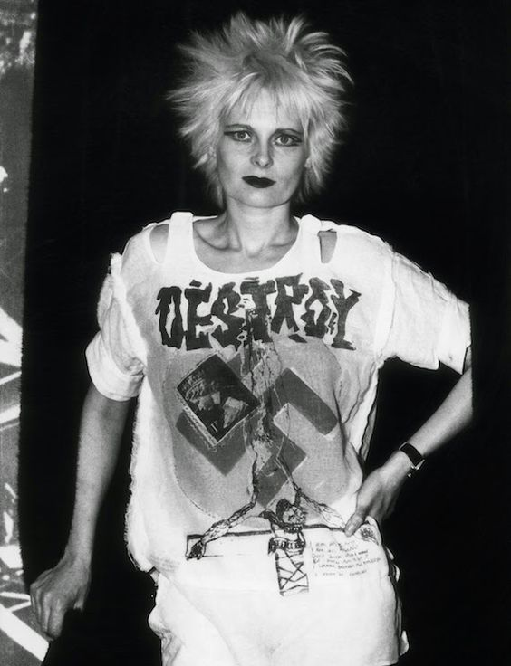
Vivienne Westwood
Punk T-shirt (1970’s)

Health & Safety
Sharp, dangerous, dangerous, risky, perilous, treacherous, dodgy, safe, protected, non-toxic, toxic, harmful, harmless, heavy, breakable, fire resistant, lightweight

Cost
Expensive, luxurious, exclusive, posh, lavish, pricey, high-priced, dear, cheap, low-cost, low-priced, economical, budget, costly, bargain, exorbitant, costly, overpriced, high-class, limited, elite
Manufacture
Hand-crafted, skilful, workmanship, expertise, technique, craft, factory–made, mass-produced, industrial, limited edition, one-of-a-kind, bespoke, time consuming, environmentally friendly
Name/Title of Design:

Date it was made/first produced:

Materials used:

What is your opinion about this design?

Inspiration/Theme
Nature, urban environment, space, science, technology, history, mythology, animals, architecture, film, fashion, books, the body, wildlife, pop culture, religion, beliefs

Style
Futuristic, Modern, traditional, Arts and Craft, Art Nouveau, Art Deco, Bauhaus, bold, contemporary, sleek, high-tech, innovative, austere, restrained, minimal, elaborate, over-the-top, flamboyant, gaudy, ornate, elegant, intricate

Colour
Bright, dark, dull, metallic, primary, secondary, bold, multi-coloured, light, contrasting, natural, earthy, pale, intense, murky, pure, deep, glowing
Colour
Bright, dark, dull, metallic, primary, secondary, bold, multi-coloured, light, contrasting, natural, earthy, pale, intense, murky, pure, deep, glowing
Colour
Bright, dark, dull, metallic, primary, secondary, bold, multi-coloured, light, contrasting, natural, earthy, pale, intense, murky, pure, deep, glowing
Colour
Bright, dark, dull, metallic, primary, secondary, bold, multi-coloured, light, contrasting, natural, earthy, pale, intense, murky, pure, deep, glowing
Colour
Bright, dark, dull, metallic, primary, secondary, bold, multi-coloured, light, contrasting, natural, earthy, pale, intense, murky, pure, deep, glowing
Colour
Bright, dark, dull, metallic, primary, secondary, bold, multi-coloured, light, contrasting, natural, earthy, pale, intense, murky, pure, deep, glowing
Colour
Bright, dark, dull, metallic, primary, secondary, bold, multi-coloured, light, contrasting, natural, earthy, pale, intense, murky, pure, deep, glowing
Colour
Bright, dark, dull, metallic, primary, secondary, bold, multi-coloured, light, contrasting, natural, earthy, pale, intense, murky, pure, deep, glowing
Colour
Bright, dark, dull, metallic, primary, secondary, bold, multi-coloured, light, contrasting, natural, earthy, pale, intense, murky, pure, deep, glowing
Colour
Bright, dark, dull, metallic, primary, secondary, bold, multi-coloured, light, contrasting, natural, earthy, pale, intense, murky, pure, deep, glowing
Colour
Bright, dark, dull, metallic, primary, secondary, bold, multi-coloured, light, contrasting, natural, earthy, pale, intense, murky, pure, deep, glowing
Colour
Bright, dark, dull, metallic, primary, secondary, bold, multi-coloured, light, contrasting, natural, earthy, pale, intense, murky, pure, deep, glowing
Colour
Bright, dark, dull, metallic, primary, secondary, bold, multi-coloured, light, contrasting, natural, earthy, pale, intense, murky, pure, deep, glowing
Colour
Bright, dark, dull, metallic, primary, secondary, bold, multi-coloured, light, contrasting, natural, earthy, pale, intense, murky, pure, deep, glowing
Colour
Bright, dark, dull, metallic, primary, secondary, bold, multi-coloured, light, contrasting, natural, earthy, pale, intense, murky, pure, deep, glowing
Colour
Bright, dark, dull, metallic, primary, secondary, bold, multi-coloured, light, contrasting, natural, earthy, pale, intense, murky, pure, deep, glowing
Colour
Bright, dark, dull, metallic, primary, secondary, bold, multi-coloured, light, contrasting, natural, earthy, pale, intense, murky, pure, deep, glowing
Colour
Bright, dark, dull, metallic, primary, secondary, bold, multi-coloured, light, contrasting, natural, earthy, pale, intense, murky, pure, deep, glowing
Colour
Bright, dark, dull, metallic, primary, secondary, bold, multi-coloured, light, contrasting, natural, earthy, pale, intense, murky, pure, deep, glowing
Colour
Bright, dark, dull, metallic, primary, secondary, bold, multi-coloured, light, contrasting, natural, earthy, pale, intense, murky, pure, deep, glowing
Colour
Bright, dark, dull, metallic, primary, secondary, bold, multi-coloured, light, contrasting, natural, earthy, pale, intense, murky, pure, deep, glowing
Colour
Bright, dark, dull, metallic, primary, secondary, bold, multi-coloured, light, contrasting, natural, earthy, pale, intense, murky, pure, deep, glowing
Colour
Bright, dark, dull, metallic, primary, secondary, bold, multi-coloured, light, contrasting, natural, earthy, pale, intense, murky, pure, deep, glowing
Colour
Bright, dark, dull, metallic, primary, secondary, bold, multi-coloured, light, contrasting, natural, earthy, pale, intense, murky, pure, deep, glowing
Colour
Bright, dark, dull, metallic, primary, secondary, bold, multi-coloured, light, contrasting, natural, earthy, pale, intense, murky, pure, deep, glowing

