Topic: Angles
At the end of this topic you should be able to:
 | I can do this
Accurately draw and measure angles  Measure this angle Draw an angle of 68$°$ | L2
Use the correct vocabulary to describe angles  1. An angle less than 90$°$ is called ______________  2. An angle equal to 180$°$ is called ______________  3. An angle between 90$°$ and 180$°$ is called __________  4. An angle greater than 180$°$ is called ___________  5. A full turn (revolution) is _____$°$  6. Angles that add up to 90$°$ are called __________  7. Angles that add up to 180$°$ are called _________ | L2
Identify types of angles  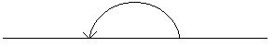  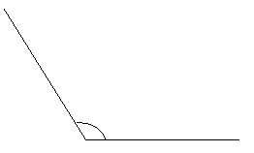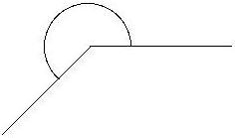  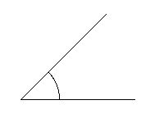 | L2  L3
Name Angles using 3 letters.
A
B
C
< ABC or < CBA

Know and use - angles on a straight line add up to 180°  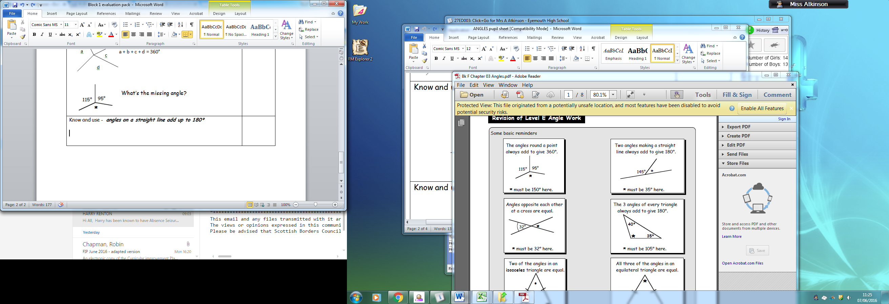What size is the angle marked *  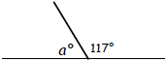  What size is angle a? | L2
Know and use - angles round a point add up to 360 degrees  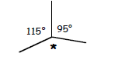  Calculate the missing angle? | L2
Know and use - the angles in any triangle sum 180°  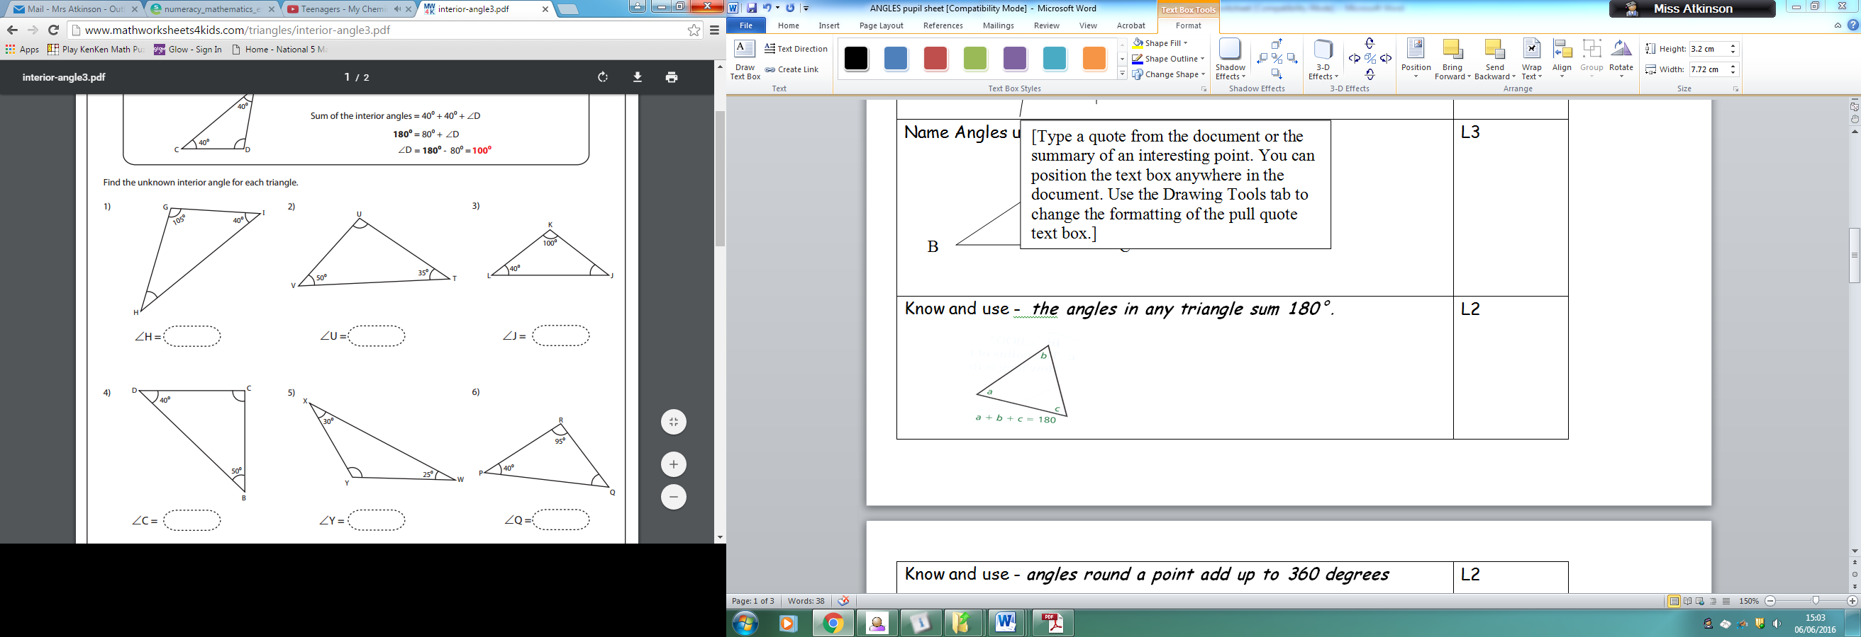  Calculate < VUT | L3

Know and use - the sum of angles in a quadrilateral sum 360°  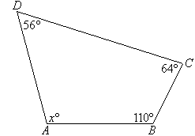Calculate the size of angle x. | L3
Know that the angles on the opposite sides of an X are equal  Fill in all of the missing angles  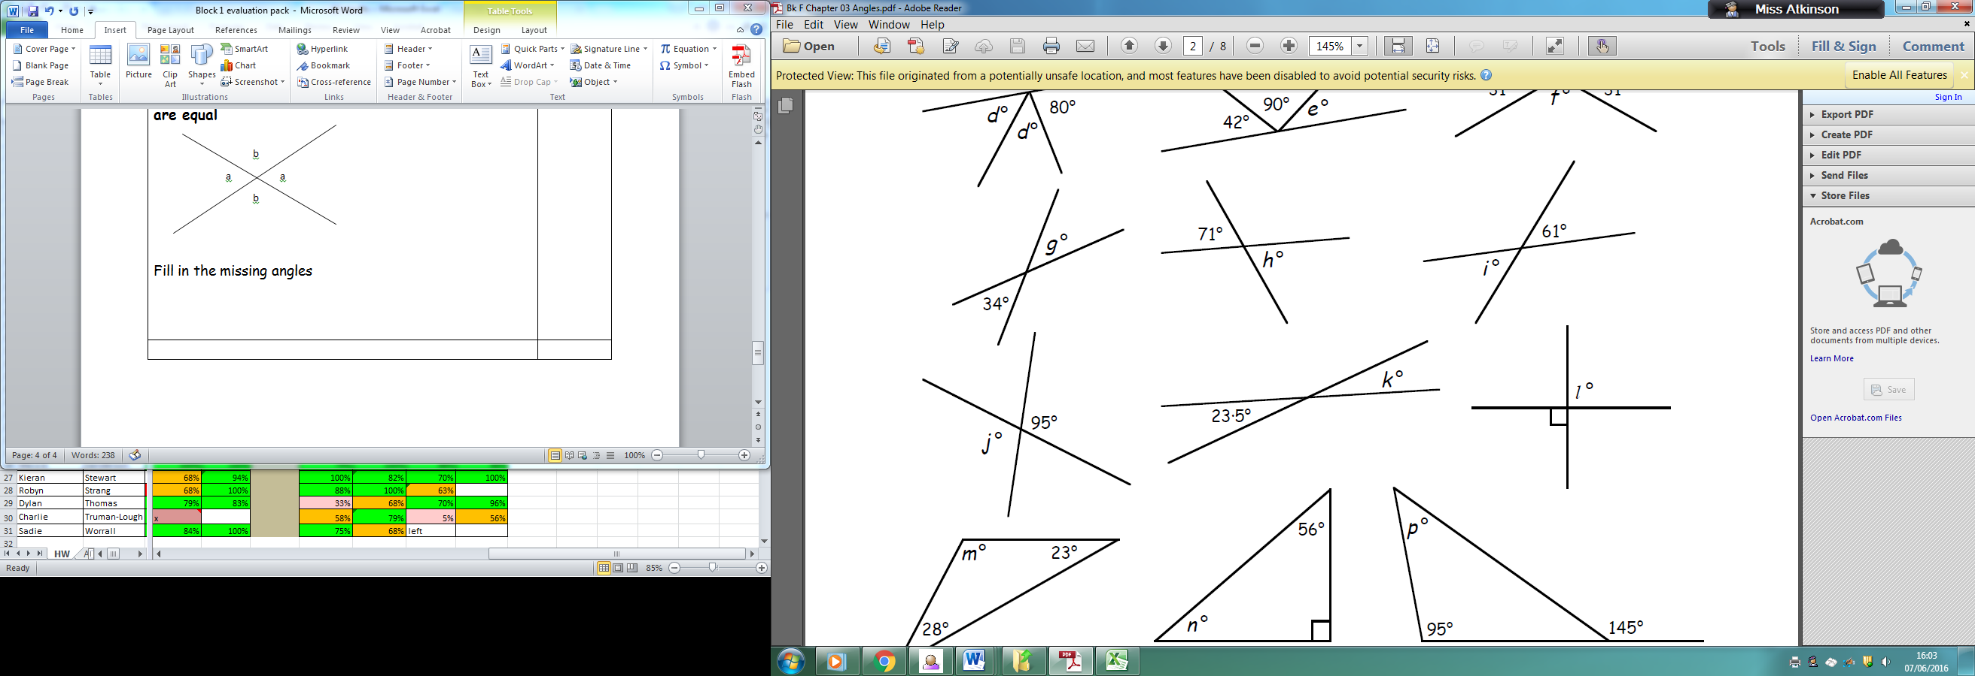 | L3
Know that the corresponding angles in an (F shape) are equal  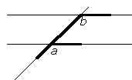fill in the size of all angles  $<a=<b=$ 117$°$ | L3
Know that alternate angles in a (Z shape) are equal  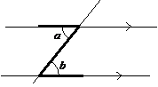Fill in the size of all angles  $$<a=<b=65°$$ | L3
Use combinations of all of the above to calculate missing angles.  Fill in all the missing angles:  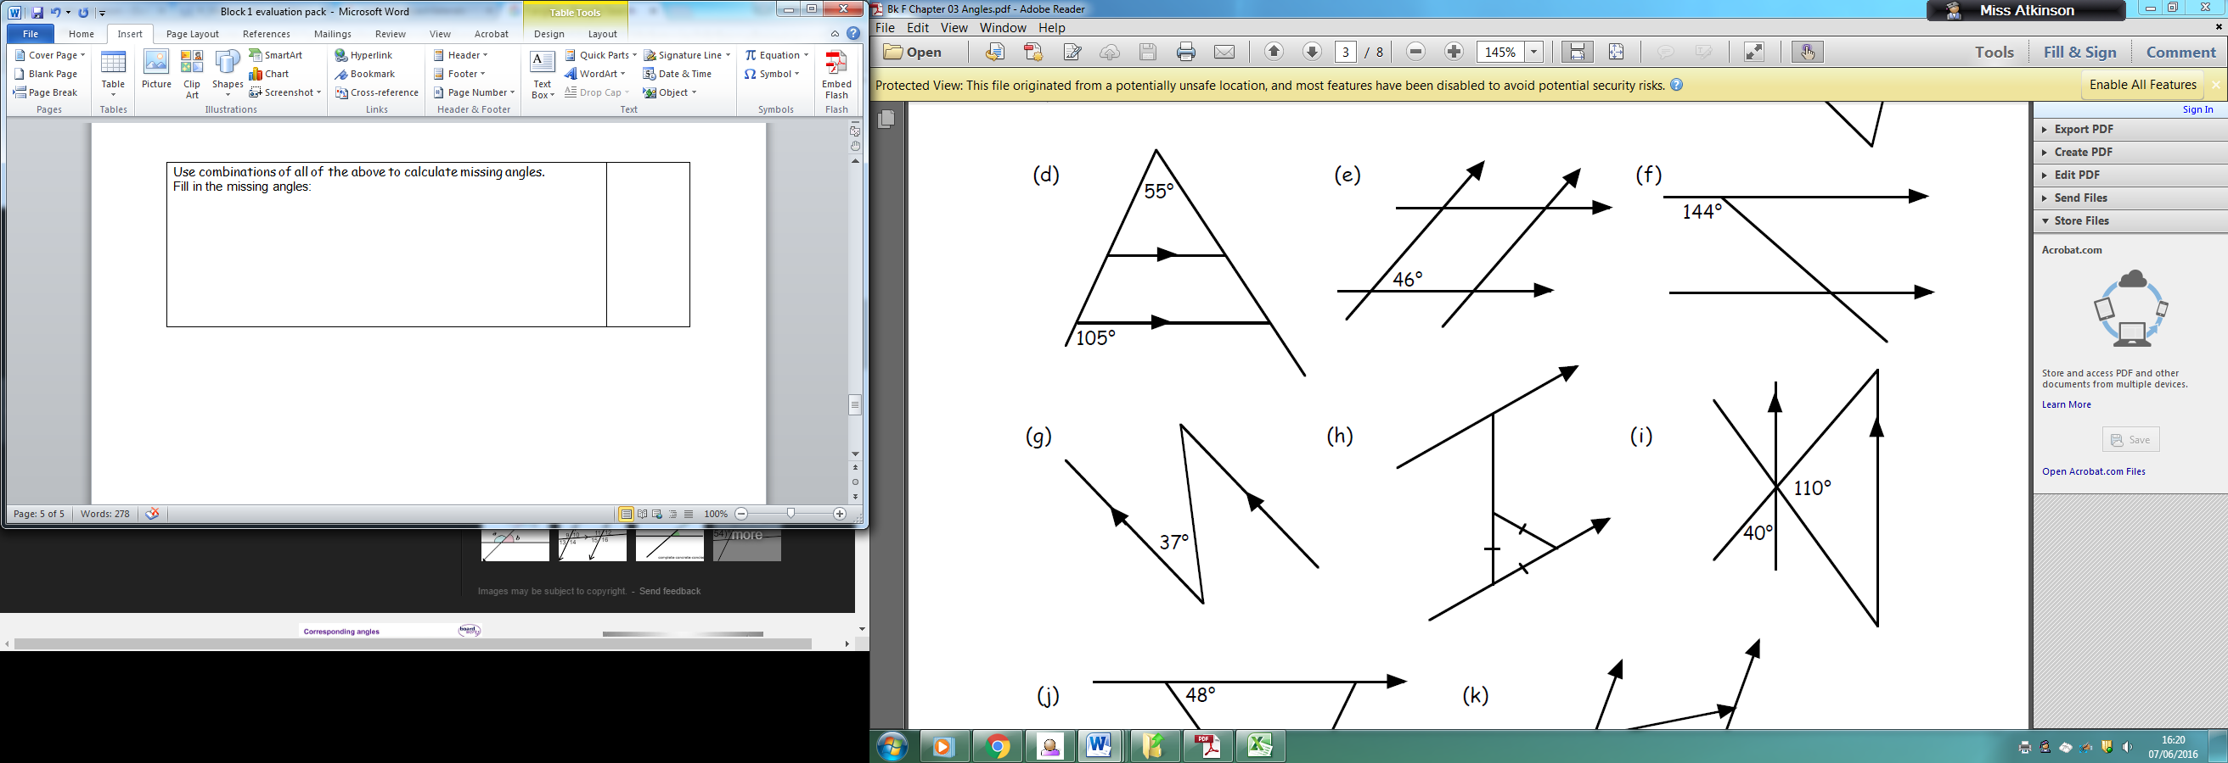  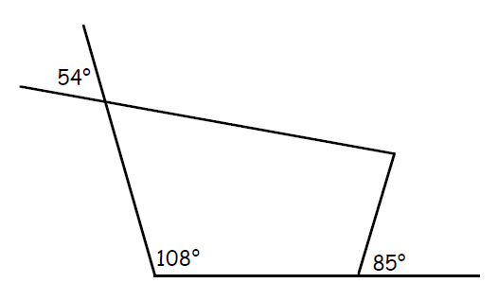 | L3
Understand the mathematics of a clock face  Calculate the angle the minute hand of the clock moves  through between 3.05pm and 3.55 pm | L3
Calculate interior/exterior angles of regular polygons  Here is a regular pentagon  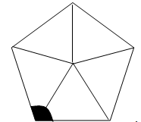  Calculate the size of the shaded angle. | L4
Self evaluation

