Eyemouth High School

Art and Design

S1
Knowledge Organiser

Home Learning

• You will work through this booklet and tasks at home, handing work to your teacher on a rotation basis in the Expressive Arts Faculty. There will be plenty of time for you to complete each task.

• Work should be completed in the sketchbook which you work on in class and can take home or your knowledge organiser books

• This will support the learning you do in class and will increase your skills in Art and Design, making your work better quality.

• You should take care over the presentation and quality of your work. Your book should be carefully laid out and completed to the highest standard possible

• Pupils will receive praise & recognition for best presentation, best effort, best standard of work and most improved work.

The Visual Elements of Art

The Visual Elements are the different things which an artist uses to create a piece of artwork. They could be described as the ‘building blocks’ of art. They are :

LINE

COLOUR SHAPE TONE FORM PATTERN TEXTURE

Your task : Create a front cover for
your sketchbook which includes the information on this page – be creative!!

LINE : line is the most basic visual element. It is simply a mark made between
two points. It can give the feeling of movement, make an object appear BOLD or delicate. TYPES OF LINE :

BOLD STRAIGHT

DELICATE HORIZONTAL BROKEN VERTICAL DOTTED DIAGONAL CURVY ZIG ZAG THICK THIN
Task: look at an object
from one
Room in your house.
Time yourself to create a drawing of the object in 5, 10, 15 minutes

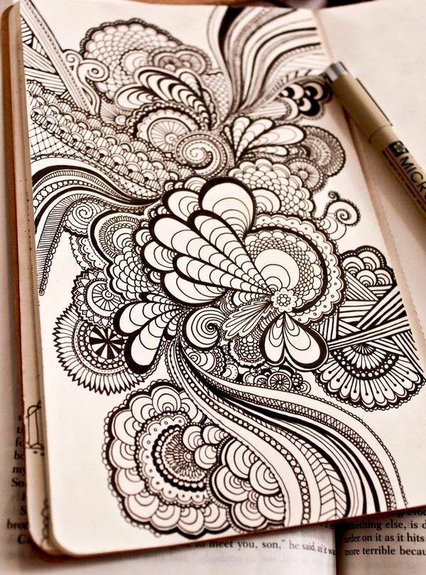
LINE DRAWING

Your task :

Using a BLACK PEN, fill half a page in your sketchbook A5 with a creative doodle using as many curly, swirly lines as possible. Use THICK and THIN lines.

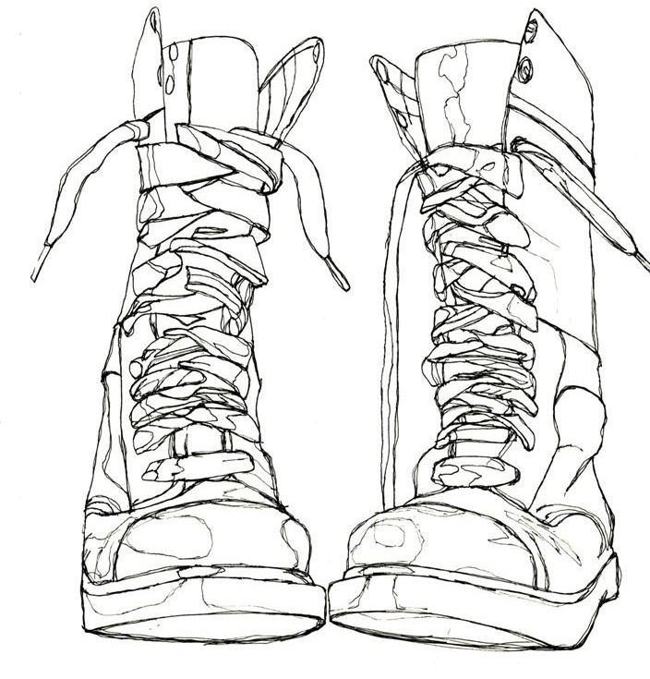
CONTINUOUS LINE DRAWING

Your task :

Draw an everyday object using ‘continuous line drawing’(boot example opposite). The only rule is that you are not allowed to take your pen off the paper at all!! Use
thicker lines in some areas by going over the same line twice

COLOUR : colour is very important to us and can be used to describe
our feelings. Artists use colour in a very careful way to give an image a certain mood or feeling. Look at the colour wheel below :

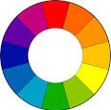
Your task :

Cut pictures from a magazine in each colour of the wheel. Glue them into your book to make your own creative colour wheel. Try to cut neatly and glue carefully. Label your wheel with these labels

COMPLEMENTARY COLOURS: These are found opposite each other on the colour wheel. Each primary colour has an opposite colour. Red &
Green, Yellow & Purple, Blue & Orange. Advertisers often use these in packaging
as they create a very STRIKING and EYE CATCHING combination.

Your task :

Create the title
‘Complementary Colours’ on a page. Fill the page with examples of packaging which uses opposite colours. You can stick the packaging on / draw it / print images off.

.

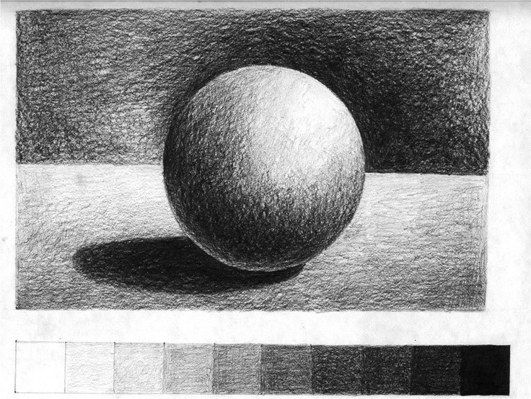
TONE : tone is the Visual Element that shows shades of light to dark. Tone is often used to create an illusion, making objects appear three dimensional.

Your task :

Copy this tonal drawing of a sphere into your book. Use a PENCIL. Copy to tonal scale at the bottom first. Try to blend gently from one tone to another. Your are aiming to go from light right through to dark.

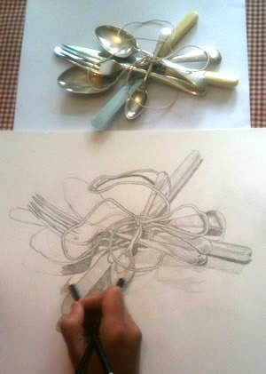
TONAL DRAWING

Your task :

Lay out 3items from a kitchen drawer in an interesting way. First, draw the shapes lightly in pencil. Then build up tone using LIGHT, MEDIUM and DARK, always blending gently from one to another.

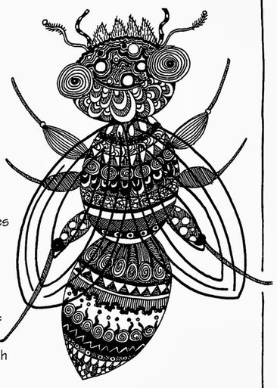
PATTERNED BUGS : A pattern is a repeated shape. Patterns can be big and bold or small and intricate.

Your task :

Draw an insect of your own design. It must have: eyes, wings, 3 body sections. Split it into sections and fill with as many different patterns as you can. Use a pencil to draw the basic bug, then pen for patterns.

TEXTURE : Texture is the Visual Element which relates to touch and surface. Textures can be rough, smooth, furry…

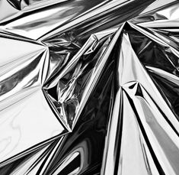
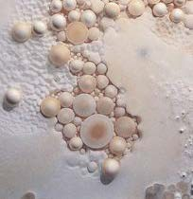

Your task :

Draw two squares 5 x 5 cms. Try to recreate TWO of these textures in a very detailed drawing using pencil.

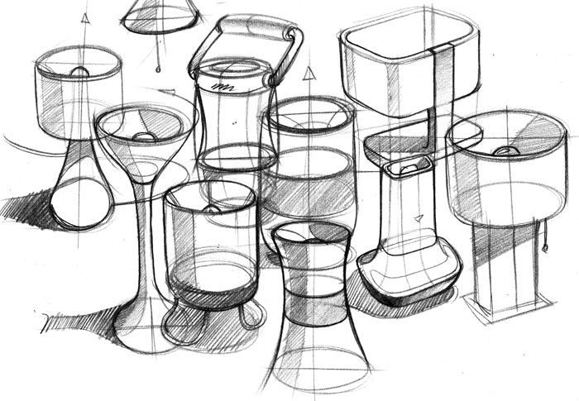
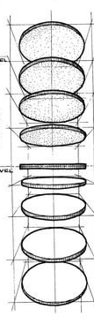
DRAWING AN ELLIPSE : Ellipses are flattened circles which you see when you look at certain objects like a cup or bottle. The top of the cup appears as
a flattened circle, depending on where you are looking at it from. Find something like a cup and saucer, or a can of juice and sketch it in pencil, focussing on the
ellipses you can see.

Your task : SKETCH an object, like a cup or can of juice, focussing on the ellipses

