Colour

Bright, dark, dull, metallic, primary, secondary, bold, multi-coloured, light, contrasting, natural, earthy, pale, intense, murky, pure, deep, glowing

Aesthetics

Attractive, industrial, funky, sophisticated, retro, original, pretty, exquisite, magnificent, good looking, attractive, striking, smart, alluring, eye-catching, appealing, desirable, handsome, cute, ugly, unappealing, distorted, over-sized, tiny, small, detailed, intricate, weird, unusual, surreal, imaginative, flamboyant, lurid, glitzy, outrageous, extravagant, understated, flashy, showy, ostentatious, organic, structured, futuristic, austere.

**Colour**

Bright, dark, dull, metallic, primary, secondary, bold, multi-coloured, light, pale, contrasting, intense, murky, pure, deep, glowing, vibrant, simple, complex, subtle, minimal, jewel-like

Shape/Form

Circular, rounded, geometric, angular, triangle, squared, sphere, cone, twisted, pointy, real, organic, man-made, constructed, abstract, simple, solid, soft, 2D, 3D, structured, natural

Target Market

Boys, girls, babies, male, female, man, woman, teenager, children, middle aged, 20’s, 30’s, 40’s, mothers, fathers, parents, grandparents, pensioners, retired, clubbers, artist, business people, affluent, working class, middle class, upper class, aristocracy, celebrities, royalty, disposable, one-off, demographic, super-rich, millionaires, theatre, film production, limited edition, mass produced, stage show, film.

Size

Dimension, proportion, big, great, bulky, fat, hefty, tiny, small, over-sized, considerable, massive, huge, immense, gigantic, vast, enormous, minute, miniature, minuscule, little, wee, teeny, petite, microscopic.

Ergonomics

Comfortable, snug, cosy, uncomfortable, efficient, effective, useful, ineffective, close, tight, secure, well made, well-fitting, fitted, body-hugging, constricted, restricting, baggy, loose, stretched, stiff, fixed, taut, wobbly, moveable, unattached, adjustable, changeable, bendable, flexible, supple, rigid.

Function

Functional, practical, helpful, beneficial suitable, successful, easy, uncomplicated, complicated, straightforward, effortless, protection, water-proof, fragile, user-friendly, durable, ventilation, to pin fabric together, to decorate, stage costume, photo shoot, film costume, party wear, catwalk, every day use, hairpiece, protection, armour, life saving, life enhancing, to advertise, promotion, medical

Materials

Artificial, synthetic, natural, faux, natural, diamonds, gems, crystals, metal, gold, silver, precious, imitation, substitute, fake, imitation, fabric, wood, fabric, leather, snake skin, paper, unusual, variety, fibreglass

Texture

Rough, smooth, bumpy, jaggy, dry, silky, light, grainy, gritty, velvety, glossy, coarse, soft, uneven, hairy

Decoration/Pattern

Detailed, striped, spotty, checked, repeated, scales, delicate, contrasting, random, floral, jazzy, busy, complex, decorative, polka dot, spotty, organic, geometric, zigzag, organic, natural

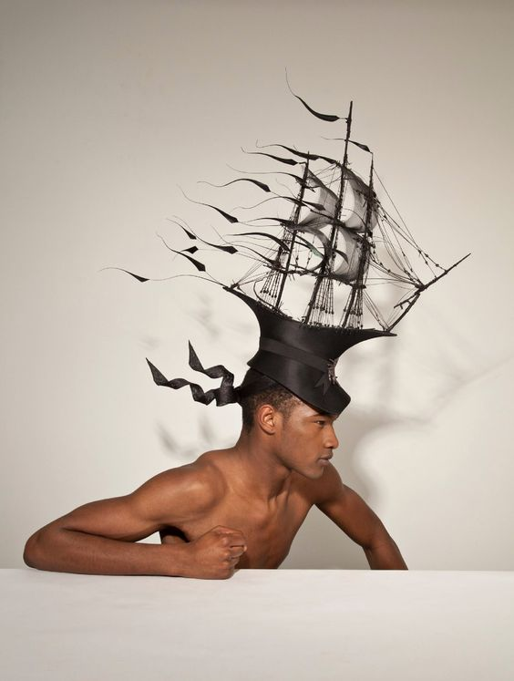

Philip Treacy

Galleon ship Hat

Health & Safety

Sharp, dangerous, dangerous, risky, perilous, treacherous, dodgy, safe, protected, non-toxic, toxic, harmful, harmless, heavy, breakable, fire resistant, lightweight

Cost

Expensive, luxurious, exclusive, posh, lavish, pricey, high-priced, dear, cheap, low-cost, low-priced, economical, budget, costly, bargain, exorbitant, costly, overpriced, high-class, limited, elite

Manufacture

Hand-crafted, skilful, workmanship, expertise, technique, craft, factory–made, mass-produced, industrial, limited edition, one-of-a-kind, bespoke, time consuming, environmentally friendly

**Name/Title of Design:**

**Date it was made/first produced:**

**Materials used:**

**What is your opinion about this design?**

Inspiration/Theme

Nature, urban environment, space, science, technology, history, mythology, animals, architecture, film, fashion, books, the body, wildlife, pop culture, religion, beliefs

**Style**

Futuristic, Modern, traditional, Arts and Craft, Art Nouveau, Art Deco, Bauhaus, bold, contemporary, sleek, high-tech, innovative, austere, restrained, minimal, elaborate, over-the-top, flamboyant, gaudy, ornate, elegant, intricate

Colour

Bright, dark, dull, metallic, primary, secondary, bold, multi-coloured, light, contrasting, natural, earthy, pale, intense, murky, pure, deep, glowing

Colour

Bright, dark, dull, metallic, primary, secondary, bold, multi-coloured, light, contrasting, natural, earthy, pale, intense, murky, pure, deep, glowing

Colour

Bright, dark, dull, metallic, primary, secondary, bold, multi-coloured, light, contrasting, natural, earthy, pale, intense, murky, pure, deep, glowing

Colour

Bright, dark, dull, metallic, primary, secondary, bold, multi-coloured, light, contrasting, natural, earthy, pale, intense, murky, pure, deep, glowing

Colour

Bright, dark, dull, metallic, primary, secondary, bold, multi-coloured, light, contrasting, natural, earthy, pale, intense, murky, pure, deep, glowing

Colour

Bright, dark, dull, metallic, primary, secondary, bold, multi-coloured, light, contrasting, natural, earthy, pale, intense, murky, pure, deep, glowing

Colour

Bright, dark, dull, metallic, primary, secondary, bold, multi-coloured, light, contrasting, natural, earthy, pale, intense, murky, pure, deep, glowing

Colour

Bright, dark, dull, metallic, primary, secondary, bold, multi-coloured, light, contrasting, natural, earthy, pale, intense, murky, pure, deep, glowing

Colour

Bright, dark, dull, metallic, primary, secondary, bold, multi-coloured, light, contrasting, natural, earthy, pale, intense, murky, pure, deep, glowing

Colour

Bright, dark, dull, metallic, primary, secondary, bold, multi-coloured, light, contrasting, natural, earthy, pale, intense, murky, pure, deep, glowing

Colour

Bright, dark, dull, metallic, primary, secondary, bold, multi-coloured, light, contrasting, natural, earthy, pale, intense, murky, pure, deep, glowing

Colour

Bright, dark, dull, metallic, primary, secondary, bold, multi-coloured, light, contrasting, natural, earthy, pale, intense, murky, pure, deep, glowing

Colour

Bright, dark, dull, metallic, primary, secondary, bold, multi-coloured, light, contrasting, natural, earthy, pale, intense, murky, pure, deep, glowing

Colour

Bright, dark, dull, metallic, primary, secondary, bold, multi-coloured, light, contrasting, natural, earthy, pale, intense, murky, pure, deep, glowing

Colour

Bright, dark, dull, metallic, primary, secondary, bold, multi-coloured, light, contrasting, natural, earthy, pale, intense, murky, pure, deep, glowing

Colour

Bright, dark, dull, metallic, primary, secondary, bold, multi-coloured, light, contrasting, natural, earthy, pale, intense, murky, pure, deep, glowing

Colour

Bright, dark, dull, metallic, primary, secondary, bold, multi-coloured, light, contrasting, natural, earthy, pale, intense, murky, pure, deep, glowing

Colour

Bright, dark, dull, metallic, primary, secondary, bold, multi-coloured, light, contrasting, natural, earthy, pale, intense, murky, pure, deep, glowing

Colour

Bright, dark, dull, metallic, primary, secondary, bold, multi-coloured, light, contrasting, natural, earthy, pale, intense, murky, pure, deep, glowing

Colour

Bright, dark, dull, metallic, primary, secondary, bold, multi-coloured, light, contrasting, natural, earthy, pale, intense, murky, pure, deep, glowing

Colour

Bright, dark, dull, metallic, primary, secondary, bold, multi-coloured, light, contrasting, natural, earthy, pale, intense, murky, pure, deep, glowing

Colour

Bright, dark, dull, metallic, primary, secondary, bold, multi-coloured, light, contrasting, natural, earthy, pale, intense, murky, pure, deep, glowing

Colour

Bright, dark, dull, metallic, primary, secondary, bold, multi-coloured, light, contrasting, natural, earthy, pale, intense, murky, pure, deep, glowing

Colour

Bright, dark, dull, metallic, primary, secondary, bold, multi-coloured, light, contrasting, natural, earthy, pale, intense, murky, pure, deep, glowing

Colour

Bright, dark, dull, metallic, primary, secondary, bold, multi-coloured, light, contrasting, natural, earthy, pale, intense, murky, pure, deep, glowing