S2 History- 60s
Key Events
1947-1989 | Cold War- Tension between the USSR and the USA starting with ideas of government- Communist or Capitalist.
1st December 1955 | Rosa Parks- Rosa refused to give up her seat on the bus for a white woman. This resulted in her being arrested, and bus boycotts in Montgomery.
1956-1969 | Space Race- a race between the USSR and the USA to get missions into space, and onto the moon.
4th September 1957 | Little Rock Nine- nine black children enrolled in Little Rock Central High School. On their first day of school, there were riots and protests.
1960 | The pill is approved for contraceptive use. By 1965, it is the most popular form of contraception in the USA.
16th-28th October 1962 | Cuban Missile Crisis- Conflict between the USA, USSR and Cuba over missiles being kept in Cuba. There were fears as these weapons could destroy part of the USA.
22nd November 1963 | Assassination of President John F Kennedy in Dallas, Texas.
28th October 1963 | Martin Luther King Jr made his iconic ‘I Have A Dream’ speech discussing racial equality.
2nd July 1964 | Civil Rights Act 1964- this act banned discrimination in public places due to race and provided integration for schools.
27th October 1967 | Abortion Act 1967 legalised abortion in Great Britian for a wide number of reasons up to 28 weeks.
1967 | Sexual Offences Act 1967- homosexulaity became legalised between men over the age of 21 in the UK.

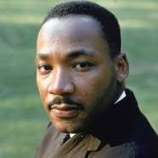
Key People
Martin Luther King Jr- Civil Rights Campaigner

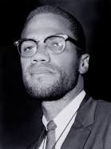

Malcolm X- Civil Rights Campaigner

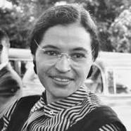

Rosa Parks- Civil Rights Campaigner
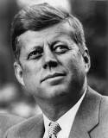

President John F. Kennedy- President of the USA Jan 1961- Nov 1963

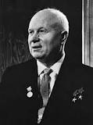
Nikita Khrushchev- Leader of the USSR from 1958-1964

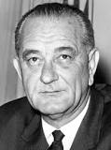
President Lyndon B. Johnson- President of the USA Nov 1963-Jan 1969

Key Words
Communism | A way of governing which means the government owns everything that is produced in the country and they share this equally among the population.
Capitalism | A way of governing which means that production is owned by the population and they get what they earn.
Segregation | The action of splitting or setting someone or something apart e.g. black and white people.
Assassination | The act of killing someone.
Boycott | Withdraw from something as a form of protest e.g. boycott using buses due to the treatment of people on them.

